Name ______________________________
Date _________________ Pd __________

The Gunpowder Empires: The Ottomans, Safavids, & Mughals

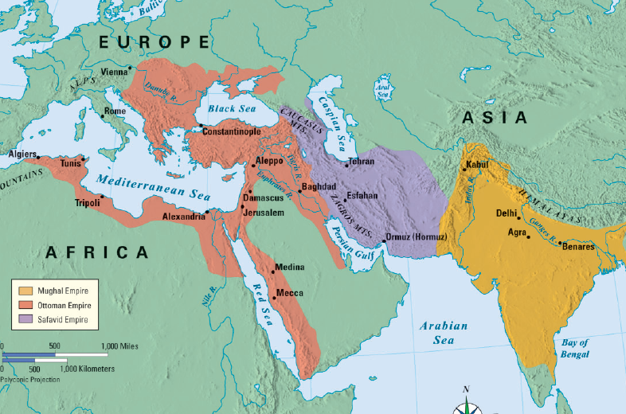
I. From 1300 to 1700, three “______________________________” dominated parts of Europe, Africa, & Asia: The Ottoman Empire, the Safavid Empire, & the Mughal Empire
A. These empires were unique but shared some similarities:
1. All 3 empires were able to __________________ neighboring people because they formed strong armies using __________ & __________________
2. All 3 empires were __________________ & ruled by Muslim leaders with ____________________________ governments made up of loyal bureaucrats
3. All 3 empires _______________ their ________________ with neighboring societies to create a high point of Islamic culture
B. The Ottoman Empire
1. The Rise of the Ottoman Empire
a. Around 1300, the _______________________________ of Anatolia were unified & formed the __________________ Empire
b. The Ottomans used _______________ & _______________ to form a powerful army & expand their territory
c. The Ottoman army included 30,000 _____________________________________ called _____________________ who were slaves that were trained to be _______________ to the government
d. In 1453, the Ottomans attacked ______________________________ & conquered the ________________________ Empire
e. By the late 1600s, the Ottomans expanded into the Middle East, Northern _____________, & Eastern __________________
2. Suleyman the Magnificent
a. Ottoman rulers were called ____________________ & they governed with absolute power
b. The greatest Ottoman sultan was ___________________________________________________ who came to power in 1520
i. Under Suleyman, Ottoman armies attacked Eastern Europe & the empire reached its ________________
ii. By the mid-1500s, Suleyman was the most __________________________________________ in the world
iii. Suleyman’s greatest accomplishment was creating a _________________ gov’t for his empire
(1) He was known as “Suleyman the __________________________” because he created a _________________________ that governed criminal & civil issues
(2) He created a simplified & fair _________ system to raise money for his empire
(3) He granted ______________________________________________________ to Christians & Jews living in the empire
iv. __________, architecture, & poetry flourished under Suleyman as the Ottoman Empire experienced a cultural renaissance
3. The Decline of the Ottoman Empire
a. To maintain their power against _____________, Suleyman & other Ottoman sultans ____________________ their brothers & jailed their sons which led to progressively __________________ leaders
b. By the outbreak of World War I in 1914, the Ottoman Empire was so weak it was known as the “______________ of Europe”
C. The Safavid Empire
1. The Rise of the Safavid Empire
a. The ______________________ were Turks living in __________________ who built a powerful gunpowder army & created an empire in modern-day ____________
b. Unlike the Ottomans who were Sunni Muslims, the Safavids believed in __________ Islam & strictly ____________________ the people they conquered
c. Safavid rulers were called _____________, using the Persian title for ____________
2. Shah Abbas
a. The greatest ruler of the Safavid Empire was ________________________ who came to power in 1587
i. Abbas ______________________ ideas from outside groups to improve the Safavid Empire
ii. He modeled Ottoman janissaries, used ____________ to employ gov’t workers, & introduced religious ________________ which helped Safavids _________________ with European Christians
iii. Art flourished, especially _________________________ that blended ____________________ & European designs
3. The Decline of the Safavid Empire
a. Like the Ottomans, Shah Abbas ________________ or _________________ his most capable sons in order to keep power
b. As a result, ______________ leaders led to a ____________________________________ of the Safavid Empire
c. While the Ottoman Empire lasted until 1922, the Safavid Empire fell in ___________
D. The Mughal Empire
1. The Rise of the Mughal Empire
a. The Mughals were ___________________ who descended from Turks, Afghans, & _________________ living in central Asia
b. Like the Ottomans & Safavids, the Mughals built a powerful ________________ with guns & cannons
2. Babar and Akbar
a. In 1494, _____________ became king of the Mughals, expanded the _____________, & began invasions into ____________ to create his empire
b. In 1556, Babur’s grandson ____________ became king of the Mughal Empire & expanded the empire into almost all of India
i. Akbar was the ___________________ of all the Mughal rulers
ii. Akbar’s greatest achievement was cultural ____________________ & ____________________ toleration
(a) He held religious discussions with _____________ & _______________ scholars
(b) He ended the _________ that _____________________ were required to pay & created a fair & affordable tax system
(c) Because he was Muslim ruling in a largely Hindu region, Akbar allowed non-Muslims to __________________________
(d) He married many wives, among them were _______________, _____________, & _______________________ women
iii. The best example of Akbar’s tolerance was his creation of a new religion called the ________________________________
(a) The Divine Faith was an example of ____________________________ because it _____________________ ideas from Islam, Hinduism, Christianity, & Zoroastrianism
(b) ___________________ hoped the Divine Faith would end _________________ between Muslims & Hindus
(c) But, the Divine Faith __________________________________________ many Muslim or Hindu converts…When Akbar ____________, so did the Divine Faith
iv. During Akbar’s reign, art flourished
(a) Mughal artists were known for their colorful paintings called _________________________
(b) Mughal architecture was known for blending of Hindu & Islamic designs
(c) The greatest example of Mughal architecture is the _______________________ which was built in 1631 by Shah Jahan
3. The Decline of the Mughal Empire
a. The Mughal Empire grew _________________ by 1700 as kings spent too much ____________________ on palaces & war
b. In addition, the large population of _________________ in India began to ___________________ against their Muslim rulers
c. ______________________________ took advantage of this weakness, _______________________ India, & removed the last Mughal emperor from power in 1858
II. Conclusions
A. The Ottomans, Safavids, & Mughals built large ___________________ empires using _____________________________ militaries
B. These empires provided new contributions in ____________, ___________, & _____________________
C. But, their decline by the 1800s allowed newly __________________________ European nations to ______________________ Asia

Comparing the Ottoman, Safavid, & Mughal Empires

 | Ottomans | Safavids | Mughals
Location of the Empire
Leaders
Law & Gov’t
Religion
Art

