Europe in Transition, 1300-1750
Chapter Three The Age of Reformation
Guided Reading
Key Terms
Act of Supremacy Augsburg Confession Electors predestination
Anabaptists Indulgence Reformation Martin Luther
Diet of Worms Ulrich Zwingli John Calvin Ignatius Loyola
Council of Trent
Review Questions
Society and Religion
- What problems within the Catholic Church contributed to the Reformation? Why were they unable to quell dissent as in past times?

Martin Luther and the German Reformation to 1525 and the Reformation Elsewhere
- Compare and contrast the ideas of Calvin, Luther and Zwingli
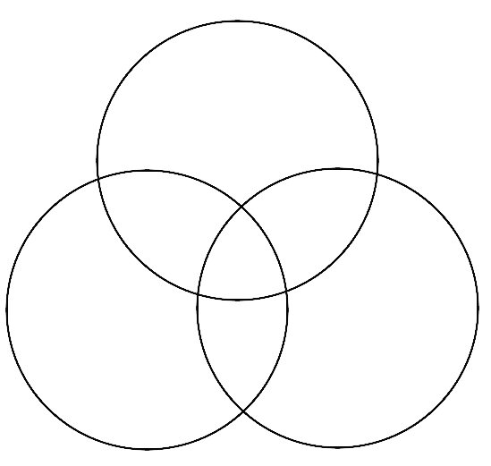
- Why did the Reformation begin in Germany? What political factors contributed to its success?

- How did the practice of Indulgences begin? Why did Luther criticize them so vociferously?

- Summarize briefly Luther’s excommunication and the Diet of Worms:

The Reformation Elsewhere
- Compare and Contrast the successes and failures of the German, Swiss and Genevan Reformation
The English Reformation
- Why did Henry VIII break with Rome?

- Was his new church initially truly protestant? How did it change under his successors?

Catholic Counter Revolution
- What was the Catholic Counter revolution? What reforms were introduced in the council of Trent?

- Was the protestant reformation good for the Catholic Church?

Family Life in Early Modern Europe
Make brief notes on the following with special attention paid to the social and economic pressures that were affecting family life in the sixteenth and seventeenth centuries:
Later marriages

Arranged Marriages

Family Size

Birth Control

Wet Nursing

Loving Families

