AP World History Summer Assignment 2014

May 2014

Dear Students,

Welcome to AP World Experience! I am looking forward to an exciting year with you and your classmates, and am busy planning for next year.

For many of you, this is your first AP class. To be successful, you will need to stay focused and work hard. You should be prepared to spend four to six hours a week outside of class on AP World History. If this does not seem realistic for your schedule, then you may want to reconsider taking this course. During the school year we will explore 10,000 years of human history, learn valuable skills, and take the AP World History Exam in May, 2015. This is an exciting class that will allow us to look at the big picture of history, trace cultures over time, and examine human interactions.

There are three summer reading books. These books can be found on my website www.khanlearning.weebly.com under the banner –Book Assignments.

The books are:
- Earth and its People (Text Book)
- Guns Germs and Steel by Jared Diamond
- AP World Review Book

These are wonderful books, but none should be read in an evening. Pace your reading throughout the summer. Complete all three parts of the assignment (Maps, Guns, Germs and Steel, and textbook chapters) listed on the back of this sheet. You will need to have these ready on the first day of class beginning August 7, 2014.
Late assignments will not be accepted as I will be quizzing you on some of the information from this packet as soon as school starts. It is important that you show me you are capable of successfully completing this independent assignment in the time allotted. This gives us a very clear picture of your ability to handle the college-level course load you will experience throughout the year.

If you have questions about the books, the notes or AP World, please contact me at khannm@fusd.net

I look forward to meeting you all!

Sincerely,

Noor Khan

Part I: Complete the following Map Activities (attached)
The world regions and physical geography are an important part of this course. Please label the maps as specified to become familiar with important geographic features and locations of early civilizations. These maps will be used for reference throughout the year. Please be NEAT!

Part II: Read Selected Chapters from Guns, Germs and Steel by Jared Diamond
The required chapters are as follows: Prologue and chapters 1 through 6 and answer the following questions.

For Guns, Germs and Steel, you have 2 questions to answer. The questions focus on PARTS of the book; read it first without taking notes, and then go back and focus on certain parts to answer the questions below.
1. Prologue: Outline Diamond’s thesis as presented here. How does Diamond prove racist assumptions false? Do you agree?

2. Part 1 From Eden to Cajamarca (Chapters 1-6): Summarize (each chapter) how environment determined the timeline of the development of man. Compare the where and when different types of societies originated, spread, or declined (Cite examples)

Your answers should be in a variety of formats. A suggested format is given in each question, but feel free to use a different format. The best answers will use a variety of these formats:

- Bullet outline  - Summaries in your own words  - timeline | - charts  - cause and effect webs  - cartoons

Part III: Read the first THREE chapters of Earth and Its People by Richard Bulliet and Period One in your AP World Review Book.

Chapter 1: From the Origins of Agriculture to the First River-Valley Civilizations 8000-1500 BCE
Chapter 2: New Civilizations in the Eastern and Western Hemispheres, 2200-250BCE
Chapter 3: The Mediterranean and Middle East 2000-500BCE

Take at least two pages of handwritten notes on each chapter (A total of 6 pages) and make sure to be able to define the vocabulary in all three chapters. Read Period One (to 600B.C.E) your AP World Review Book. This will complement the chapters in Earth and its People.

Due Dates & Assessments:
All assignments for History will be due the first day of class and all readings should be complete. There will be a history test (25 MC and three short answer essays covering all summer writing topic) on Friday of the first week.

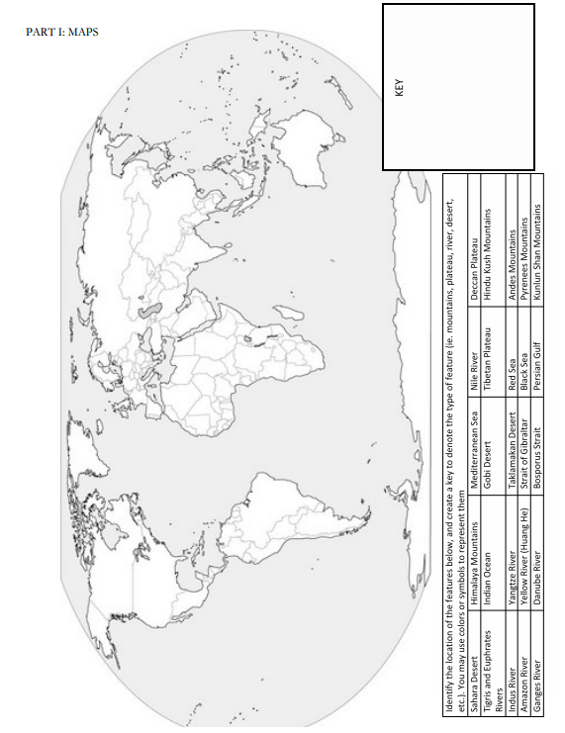

Ap World History: World Regions: A Big Picture View
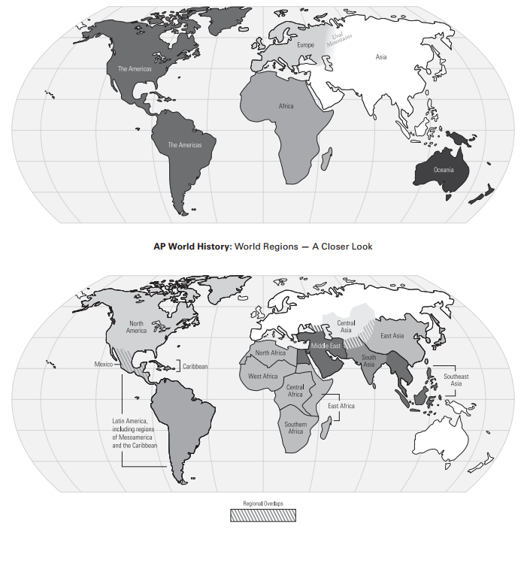
Use these maps to help you identify the AP Regions on the subsequent maps.

Africa and Southwest Asia

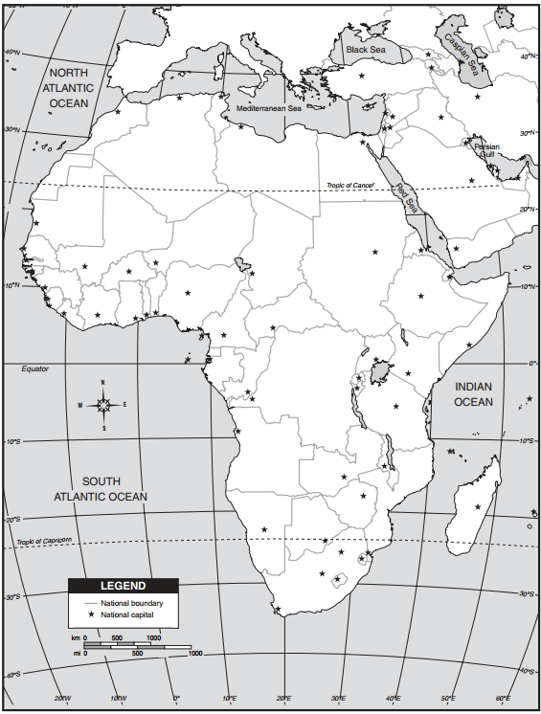
Directions: Outline the location/place of the following from Period I (to 600 B.C.E) then answer the questions that follow. You may use a separate page to write your answers.

Africa
• Nile River Valley (Egyptian and Nubian Civilizations)

• Origins and spread of the Bantu
(Bantu migration)

Use the following link to help
you, or Google “bantu migration”
http://khanlearning.weebly.com/uploads/1/3/8/8/13884014/bantu_migrations__great_zimbabwe_freemanpedia.pdf

Southwest Asia
• Mesopotamia

• Hittite Kingdom
http://khanlearning.weebly.com/uploads/1/3/8/8/13884014/hittites.pdf

Questions
1. Why do you think the Bantu migrated southward rather than northward?

2. What role does geography play in the development of civilization?

Please color the AP regions for Africa and Southwest Asia using the map included (labeled “AP World Regions Map” on page 4) and create a key:

Europe
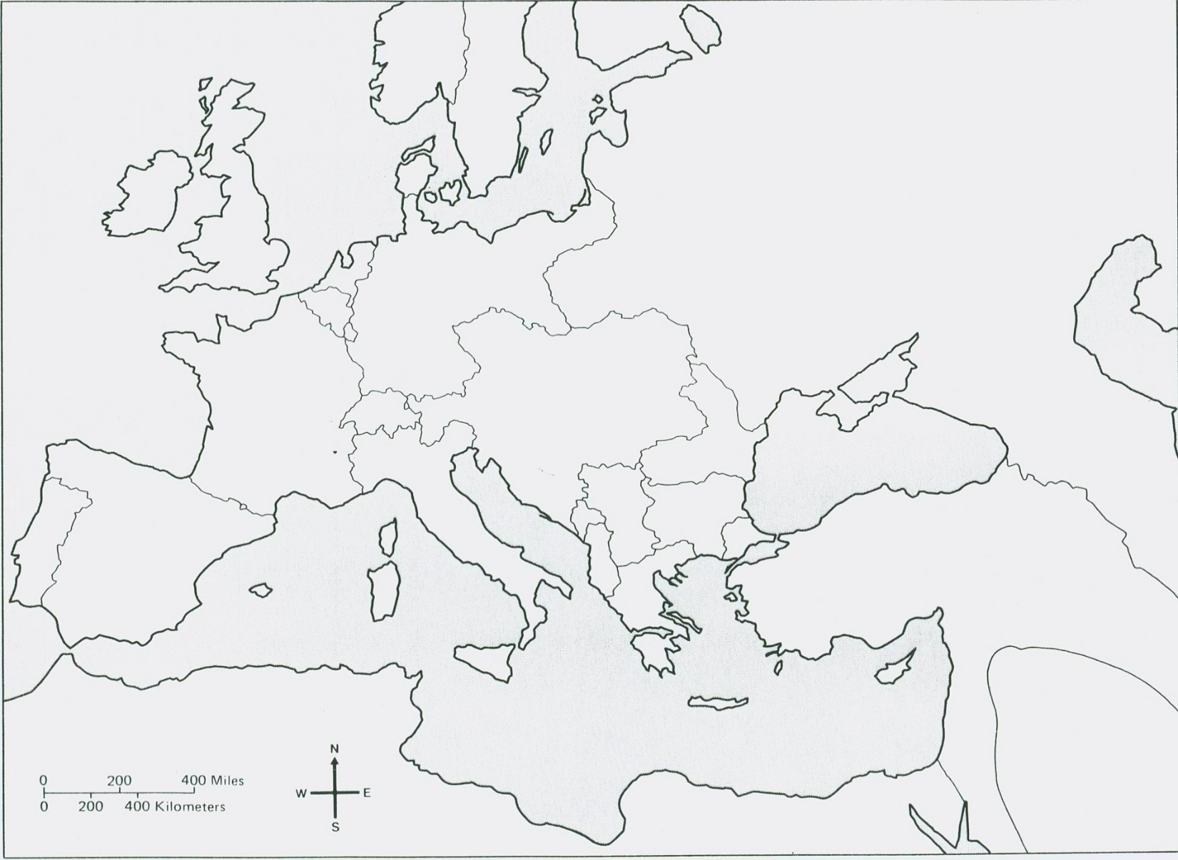
Directions: Outline/label the location of the following from Period II (600 B.C.E. to 600 C.E.) then answer the questions that follow.
Label:  - Greek City States  - Athens  - Sparta  - Region of Macedonia  - Roman Empire  - Mediterranean Sea  - Bosporus Strait  - Black Sea | Questions:  1. What do you think is the likely impact of the Mediterranean on the European civilizations?  2. Why might a city on the Bosporus Strait become a center of trade? | 3. Which geographic features might have kept the Greek city-states from uniting?
Please color each of the following a different color
Western Europe Eastern Europe

South and Southeast Asia
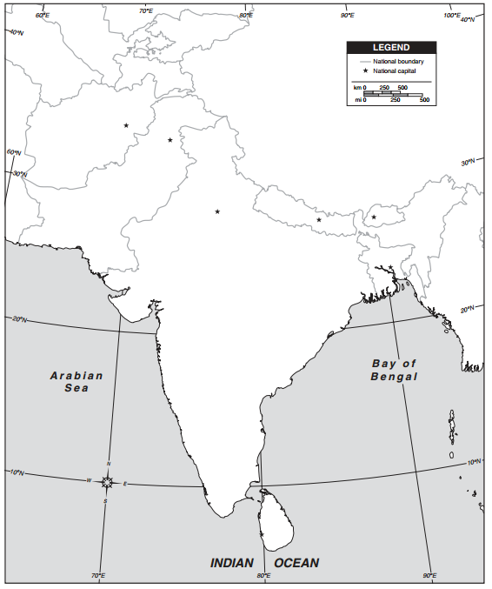
South Asia
Directions: Outline/label the location of the following then answer the questions that follow

South Asia
• Indus River
• Ganges River
• Himalayan Mountains
• Hindu Kush Mountains
• Khyber Pass
• Indus Valley Civilization

Draw an arrow representing the migration of the Aryans (Indo Europeans) into South Asia. Google “Aryan migration”

Question
Identify one geographic feature in South Asia and explain how it may have impacted the development of South Asia.
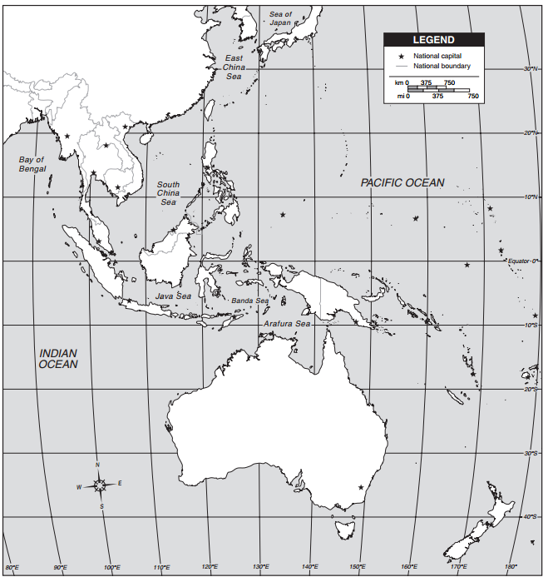
Directions: Label the map of South East Asia with the following Modern Day countries in Southeast Asia.

Southeast Asia
• Thailand
• Laos
• Cambodia
• Malaysia
• Indonesia
• Vietnam
• Burma
• Philippines
• Papua New Guinea
Southeast Asia
Central America, the Caribbean, and South America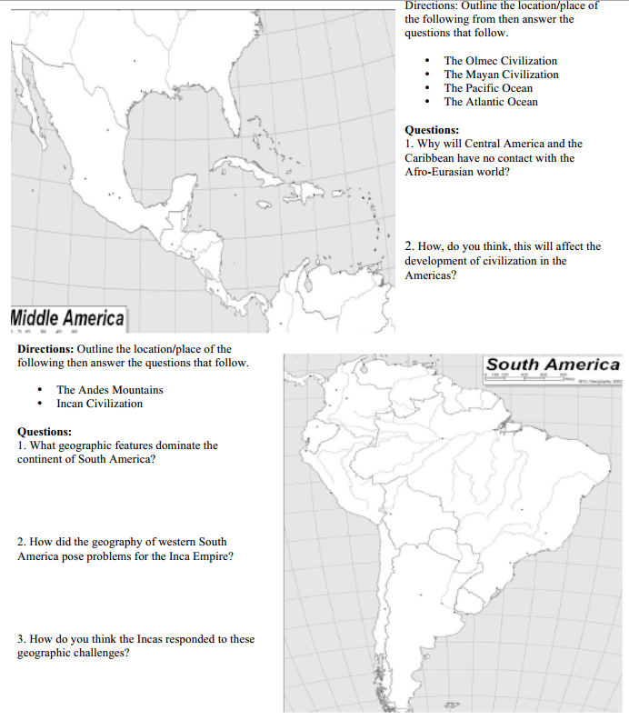

East Asia
