Homework: Continuity and Change over Time Essay

One of the three essays that you will be asked to write on the AP World History Exam is a Continuity and Change over Time essay (CCOT). This is a style of essay that examines how something changes and stays the same over time. For example, we could look at how world trade patterns changed from 1450 to 1750 C.E, or how the role of women changed in the Middle East from 1900 to present. This essay forces us to examine the beginning situation, what caused it to change, and its ending condition. However, we must also consider what stayed the same.

Write your own CCOT essay about yourself. You should pick 3 areas to specialize in: education, friends, responsibility, religious life, family, athletics, music, or another topic of your choosing. In regards to a time frame, start the essay wherever it’s appropriate for the topic. More advanced essays will look at 4‐5 different specialty areas (1 paragraph for each) and will be able to tie them all together to give a more thorough analysis of you.
The Question Prompt: What significant changes took place in your life from the age of 5 until the present time in any three specialty areas listed below and what significant historical context led to that change (or continuity) in your life.
- Education
- friends
- responsibility
- religious life
- family
- athletics
- another topic of your choosing
The chart in the next page should be completed to help you plan before you write and to provide an organizational structure for your essay. You will use a similar planning chart throughout the year as we write other CCOT essays. If you are striving for a more advanced essay, you would have 3‐4 different charts (1 for each category).

I don’t expect perfect essays but I do expect you to give it a try. Basic essays will have a minimum of three paragraphs with a clear thesis. A basic essay will earn a maximum 2.5-3.0. In order to earn a 3.5-4, you will need to attempt the more advanced essay and have a logical thesis tying it together. By completing this essay, we will have a chance to understand your writing ability as we begin the class and you will have a chance to practice one of the three essay structures we will focus on (and the one that is typically the hardest for students on the AP exam).

Essay should be typed (Double-spaced, 12 pt. font) and submitted for peer review on the due date August 13/14, 2014. Final Essay is due on August 15, 2014

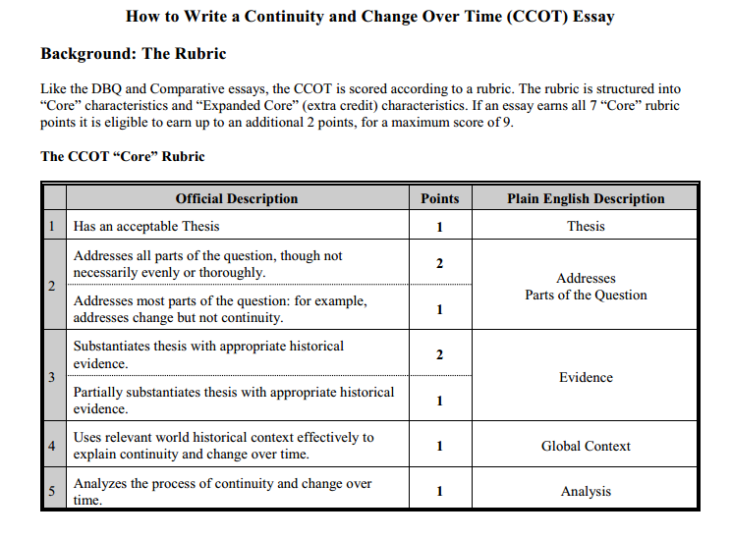
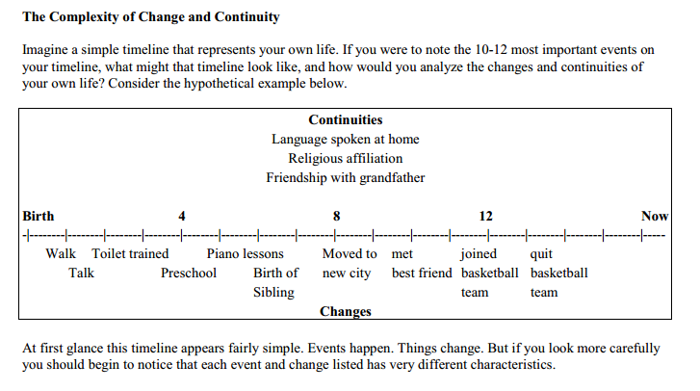

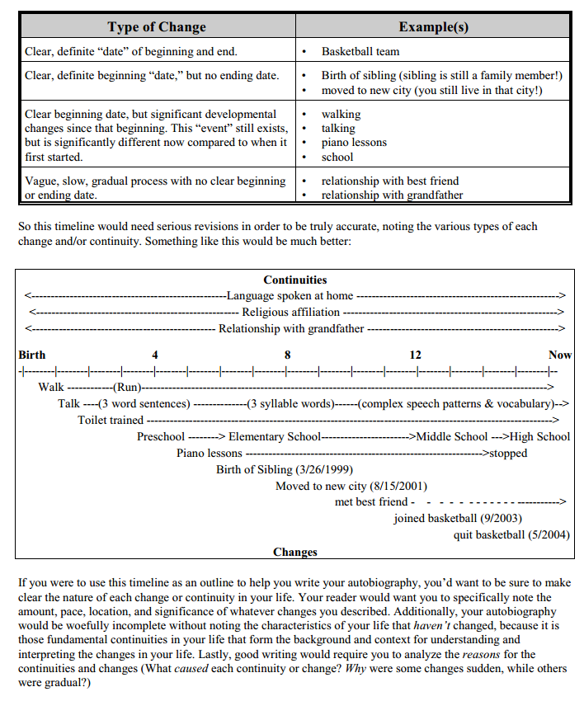

On the next page, you have a graphic organizer to organize your thoughts to write your first CCOT essay. Rubric is placed at the end of this document.
Change or Continuity #1 |  | Change or Continuity #2 | Change or Continuity #3 | Change or Continuity #4
Evidence |  | Evidence | Evidence | Evidence
Reason for change/continuity & Explanation |  | Reason for change/continuity & Explanation | Reason for change/continuity & Explanation | Reason for change/continuity & Explanation
World Historical Context
What was happening in the world during the key events that incurred change in your life? (For example how did the new millennium Year 2000, information technology boom, tech migration, etc. affect your life?)

 | Thesis

Check Off Sheet

1. Change and Continuity
- Show both in essay if possible.
- You will usually see more change than continuity.
- Examine all aspects of civilization or group you are discussing.
- PERSIAN

2. Read the Question
- Make sure you understand what the question is asking.
- Are there specific aspects of the civilization or group you are to address? (social, political, economic)
- Make sure you address the time period parameters given in the question.

3. Rubric
- Thesis that addresses issues and time period.
- Address all parts of the question.
- Back up your thesis with historical evidence. This is the meat to your essay.
- Show the change or continuity by discussing historical context.

4. Essay Outline – Introduction Paragraph
- Well written thesis that address all issues discussed in the question and the time period
- Background/filler information to make a well rounded paragraph
- Pick 3 issues/aspects to discuss if none are provided in the question.

5. Essay Outline – Second Paragraph
- Addresses first issue from beginning of time period to the end of time period
- Topic sentence for the paragraph
- At least four other sentences in which you give historical evidence to back up the thesis
- Will show a change or continuity

6. Essay Outline – Third Paragraph
- Addresses second issue from beginning of time period to the end of time period
- Topic Sentence
- At least four other sentences to provide historical evidence to support thesis
- Will show a change or continuity

7. Essay Outline – Fourth Paragraph
- Addresses third issue from beginning of time period to the end of time period
- Topic Sentence
- At least four other sentences that support the thesis with historical evidence
- Will show a change or continuity

8. Essay Outline - Conclusion
- Restates the thesis in a different way
- Sums up the change/continuity of the issues addressed

General Rules for Essays
- All essays can be hand written or typed. Use 12pt. font (research states you remember material better when it is hand written)
- I grade using the AP Rubric.

Let’s Work It Out
- Your Essay Question:
- Thesis:
- What are the three specified areas?
- What are the time period parameters?
- Is there change or continuity, or both?
- What can your thesis be?
- How will you set up the rest of your essay?

Once you write your autobiographical essay, you will learn to convert these principles from the autobiographical timeline example to an actual CCOT essay and you’ll quickly realize why the CCOT has earned a reputation as the hardest essay on the APWH exam. It requires students to quantify the nature, amount, and timing of continuity and change. Merely acknowledging continuity and change isn’t sufficient. Essays should note the amount, timing, location, causes, and effects of continuity and3 change relevant to the question. The more specific you can be about these characteristics, the better your score.
So how does one do this?
Each quarter you will practice CCOT thesis paragraphs of various question prompts and you will write a complete CCOT essay. Over the year, my plan is for you to practice and write minimum of 4 CCOT essays before the AP College Board exam in May 2015.

