AP European History: Chapter 5
European State Consolidation in the Seventeenth and Eighteenth Centuries
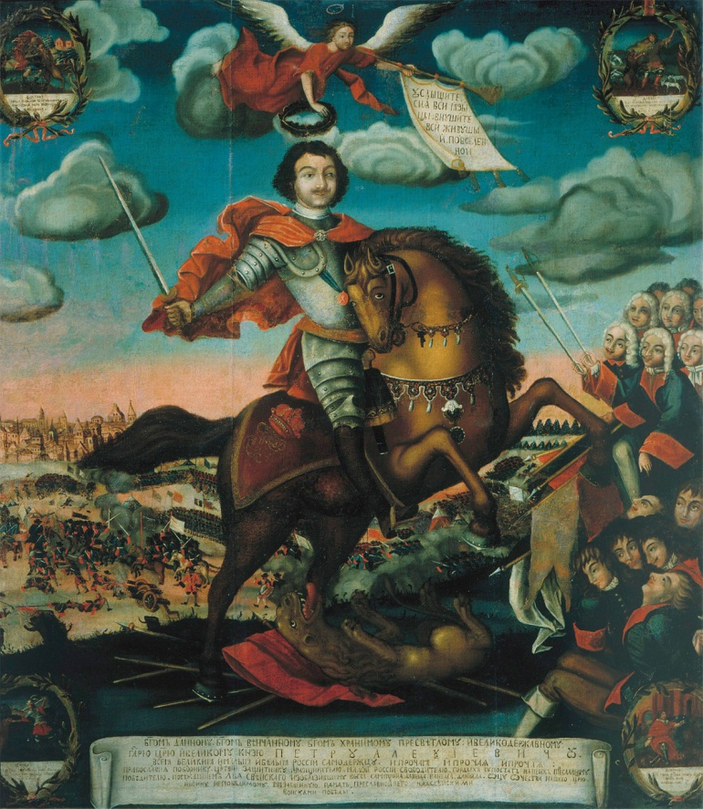
Peter the Great (r. 1682–1725), seeking to make Russia a military power after West European models reorganized the country’s political, social, and economic structures. He also radically changed the relationship of the Russian Church to the Russian state. His reign saw Russia enter fully into European power politics.
The Apotheosis of Tsar Peter the Great 1672–1725 by unknown artist, 1710. bpk, Berlin/Museum of History, Moscow, Russia/ Alfredo Dagli Orti/Art Resource, NY

Section 1: Netherlands:
The Golden Age – 1600’s
- As opposed to all other European nations at the time, it was a _____________
- Holland dominated the States General, the central government of the Netherlands, but distrusted the House of __________
- For a period of time (1688-1714) the Netherlands became a monarchy under William III of ____________
- Dutch revert to a republic in 1714 when war with France ended
- Home to great religious _____________ and a haven for _______
- The Dutch had thriving farms, fish and textile industries, plus a trade industry that reached all the way to ______ ________

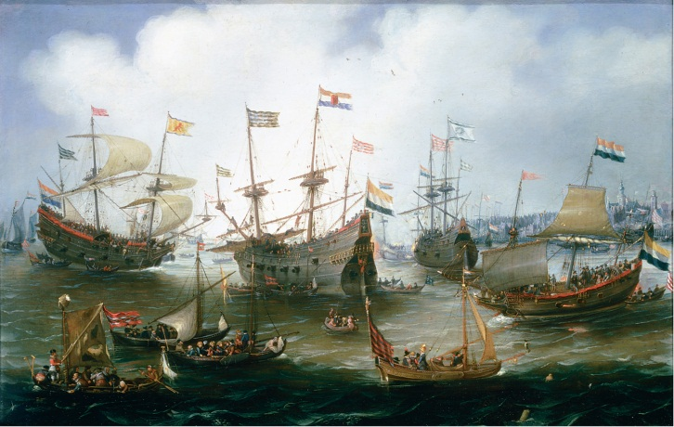
The technologically advanced fleet of the Dutch East India Company, shown here at anchor in Amsterdam, linked the Netherlands’ economy with that of southeast Asia.
Andries van Eertvelt (1590–1652), The Return to Amsterdam of the Fleet of the Dutch East India Company in 1599. Oil on copper. Johnny van Haeften Gallery, London. The Bridgeman Art Library

Economic Decline
in the Netherlands
- No strong _____________ replaced William III after his death in 1702 ( stadholder means what?)
- Surpassed in naval supremacy by the ___________
- Fishing and trade industries declined
- Only financial institutions kept the Dutch from complete insignificance
Section 1 Questions:
- What were the sources of Dutch prosperity and why did Netherlands decline in the eighteenth century?
- In what way was Dutch political organization connected to Dutch Prosperity?
(questions 1 and 2 lead you write the essay)
Short Essay: What was the Dutch Golden Age and what led to its decline?

Section 2: Two Models of European Political Development in the 17th Century
- England –_____________ _____________ – a limited monarchy where the monarch is subject to the law and the consent of parliament
- France – __________ ___________ – strong centralized monarchies, where the royal power is dominant

Section 2 Questions
- What factors led to the different political paths taken by England and France in the 17th century?
- Explain the difference between Republic, Parliamentary Monarchy and Political Absolutism. Give specific examples.

Section 3: Constitutional Crisis and Settlement in Stuart England – James I
- Peacefully takes throne in 1603, a strong believer in the __________ ___________ of kings
  - Levied new custom duties known as impositions to raise money
  - Rebuffs Puritans and maintains Anglican episcopacy, causing religious dissenters to leave England for North America
  - Court was center of ________ and corruption with his favorite duke (lover?) of Buckingham
- Doubts about James I commitment to ____________
  - Makes peace with Spain
  - Tries to relax penal laws against ___________
  - Hesitant to support German __________ in Thirty Years’ War
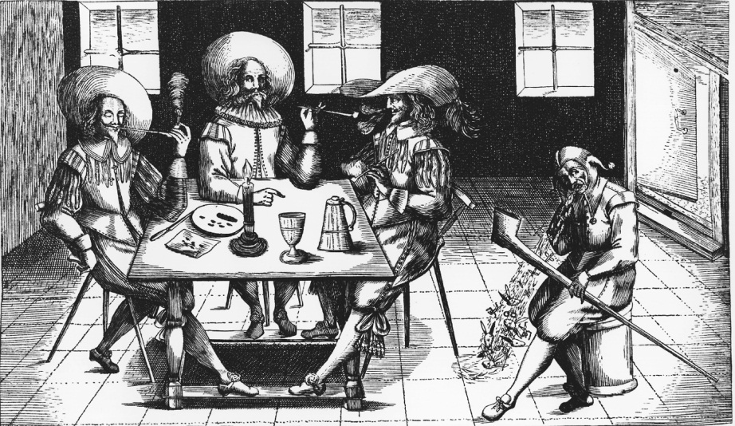
Practically from the moment of its introduction into Europe tobacco smoking was controversial. Here a court jester is portrayed as exhaling rabbits from a pipe as three pipe-smoking gentlemen look on.
Christel Gerstenberg/Fine Art Value/Corbis

Stuart England – Charles I
- To fund a new war with Spain, Charles levied tariffs, duties, and ___________
- Parliament would only give Charles funds if he agreed to the Petition of ________ stating that no forced loans or taxations could happen without the consent of Parliament
- Charles ____________ Parliament from 1628 to 1640
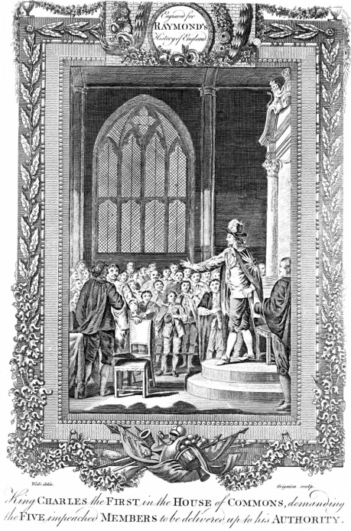
One of the key moments in the conflict between Charles I and Parliament occurred in January 1642 when Charles personally arrived at the House of Commons intent on arresting five members who had been responsible for opposing him. They had already escaped. Thereafter Charles departed London to raise his army. The event was subsequently often portrayed in English art. The present illustration is from an eighteenth-century engraving.
The Granger Collection, New York

Charles I – Years of Personal Rule
- Makes peace with Spain and France to conserve limited resources
- His chief advisor Thomas Wentworth institutes strict efficiency and administrative ___________
- Scottish rebellion against his attempt to enact the English Episcopal system leads to the reinstallment of Parliament

Long Parliament and Civil War
- Parliament is divided over __________ – extreme and moderate ____________ wanted to abolish the Book of Common Prayer, but conservatives wanted the Church of England to remain
- Charles invades Parliament, intending to ____________ his rivals
- ______ _______ ensues between the king’s supporters (___________) and the parliamentary opposition (_____________)

Oliver Cromwell
- Led ________________ (Round Heads) army in civil war
- Parliament wins civil war, and in response, _________ Charles I and _________ the monarchy, the House of Lords, and the Anglican Church
- Ran basically a military ____________ which brutally conquered Catholic countries Scotland and Ireland
- Introduced Puritan prohibitions against ____________, theatre going, and __________
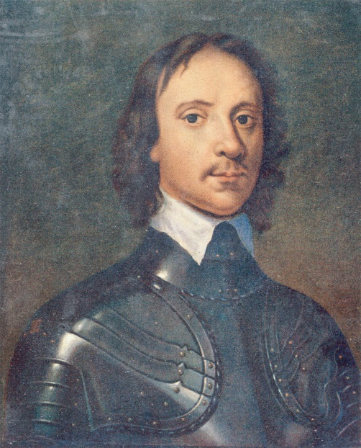
Oliver Cromwell’s New Model Army defeated the royalists in the English Civil War. After the execution of Charles I in 1649, Cromwell dominated the short-lived English republic, conquered Ireland and Scotland, and ruled as Lord Protector from 1653 until his death in 1658.
Anthony Van Dyck/Beryl Peters Collection/Alamy

The Restoration of the Monarchy
- When Cromwell dies, the people are ready to reestablish the monarchy and the Anglican Church
- Charles II is named monarch and he reintroduces the status quo from before Cromwell

Charles II
- Believed in religious ___________ and planned to convert to Catholicism
- In attempt to unite the people behind the war with Holland, issues Declaration of Indulgence suspending all laws against ______________ and non-Anglican Protestants
- Parliament forces Charles to rescind the act and passes the Test Act – requiring all civic and military officials to swear an oath against the doctrine of ___________________
- Popish Plot – believing there was an assassination plot against the king to put James in power, opposition Parliament members known as Whigs try and _____________ innocent Catholics
- Charles responds by executing Whig members for treason, converts to Catholicism on his death bed, and leaves James a Parliament filled with royal friends

The Glorious Revolution
- James II – repeals the Test Act, puts Catholics in positions of power, and issues another Declaration of Indulgence permitting religious _____________
- Parliament, afraid of a Catholic heir to the throne, invites William of Orange to ___________ England
- James flees to France – William III ( William of Orange) and Mary (James’s eldest Protestant daughter) succeed to the throne in the bloodless Glorious Revolutionoth
- Mary and William III recognized the English Bill of Rights that limited the ____________ of the monarchy and guaranteed the civil liberties of the ________________ __________ class
- England becomes a _________ monarchy and permits worship of all Protestants, but not Catholics (The ___________ Act of 1689)
- Act of Settlement puts King George I on the throne

The Act of Walpole
- Sir Robert Walpole dominated English politics from 1721 till 1742 based on his royal support, ability to handle the House of Commons, and control over government patronage
  - Promoted _________ at home and abroad
  - Spread ___________ from North America to India
  - Built the military, especially the navy, making Britain a world __________
- Walpole’s efforts resulted in England becoming a military power with both religious and political _____________.
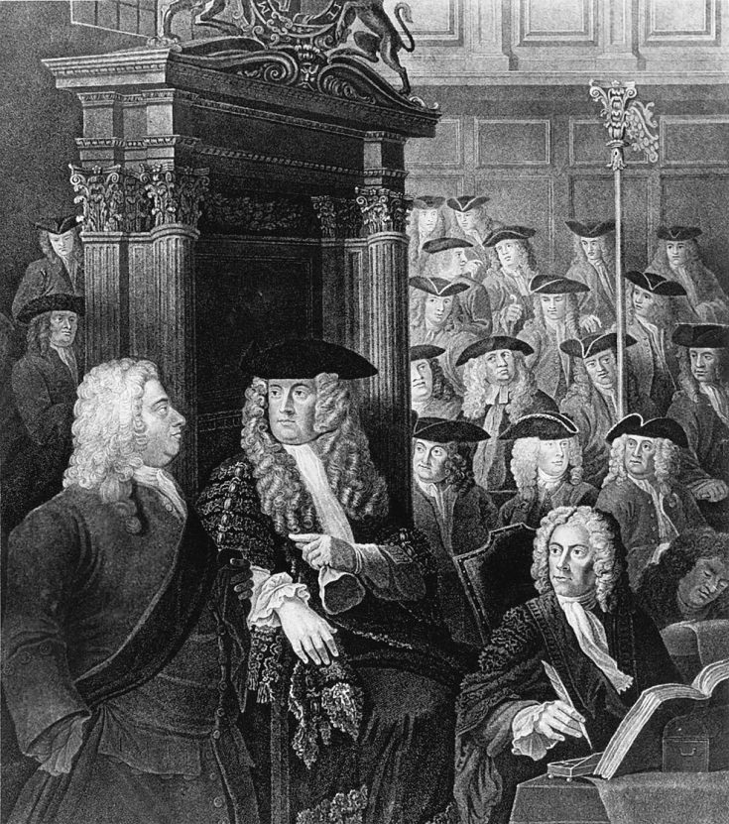
Sir Robert Walpole (1676–1745), far left, is shown talking with the Speaker of the House of Commons. Walpole, who dominated British political life from 1721 to 1742, is considered the first prime minister of Britain.
Mansell/TimePix/Getty Images, Inc.

Section 3 Questions
- How did the conflicts over taxation and religion lead to civil war in Stuart England?
Conflicts Leading to Civil War
Conflicts over taxation | Conflicts over Religion

- What was the Glorious Revolution and why did it take place?
- What role did Puritanism (religion) play in the English politics?

Section 4 The rise of Absolute Monarchy in France: The world of Louis XIV
- Takes over country upon death of Cardinal _____________ in 1661
- Was an __________ monarch, but often conferred with councils and the regional judicial bodies called the parlements
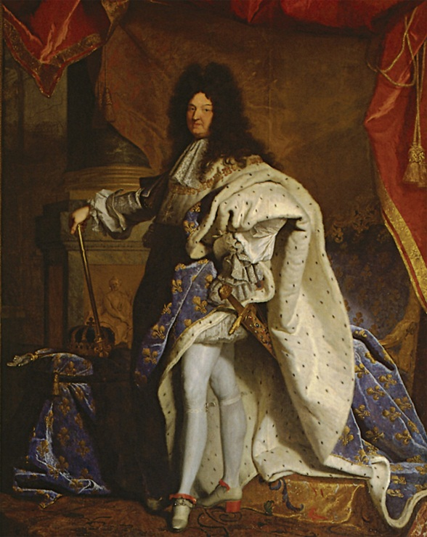
- Later curtails parlements’ power, but is supported by some of them anyway
Louis XIV of France came to symbolize absolute monarchy though such government was not as absolute as the term implied. This state portrait was intended to convey the grandeur of the king and of his authority. The portrait was brought into royal council meetings when the king himself was absent.
Hyacinthe Rigaud (1659–1743), Portrait of Louis XIV. Louvre, Paris, France. Dorling Kindersley Media Library/Max Alexander. © Dorling Kindersley, courtesy of l’Etablissement public du musée et du domaine national de Versailles

Versailles – Louis XIV
- Huge palace that was built for Louis XIV and housed thousands of important nobles, royal officials, and servants
- The _______ ________ liked items that were lavish and ornate
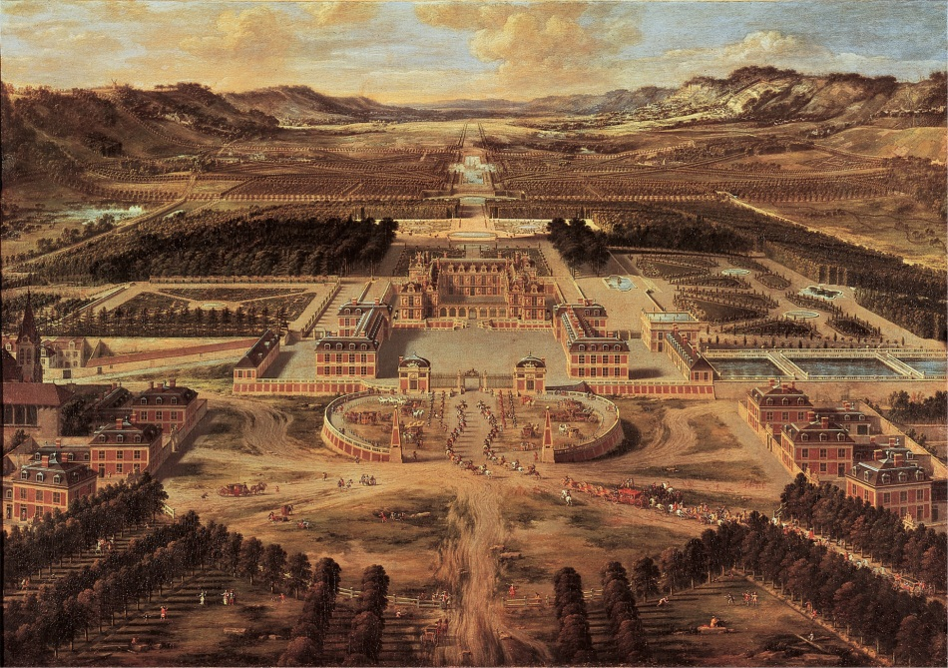
Versailles Louis XIV constructed his great palace at Versailles, as painted here in 1668 by Pierre Patel the Elder (1605–1676), to demonstrate the new centralized power he sought to embody in the French monarchy.
Pierre Patel, Perspective View of Versailles. Chateaux de Versailles et de Trianon, Versailles, France. Musée du Château de Versailles/Gianni Dagli Orti/The Art Archive at Art Resource, NY

Divine Right – Louis XIV
- Ruled by what was believed to be rule by God or “__________ right of kings”
- Still, Louis was less of an absolute monarch than others, concentrating on making war and peace, the regulation of religion, and the oversight of economic activity

Louis’s Early Wars
- Wanted to secure France’s borders near the Netherlands, Spain, and the Hapsburg Empire
- Treaties signed to end wars with the Netherlands and the Holy Roman Empire __________ France’s territory to the north and east

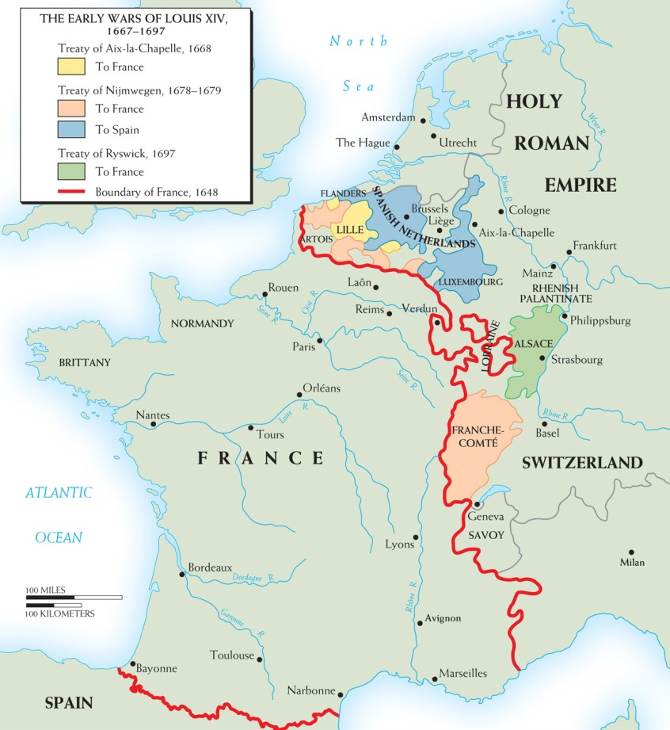
Map 13–1 THE FIRST THREE WARS OF LOUIS XIV This map shows the territorial changes resulting from Louis XIV’s first three major wars (1667–1697).

Louis’s Repression of Religion
- Suppression of the Jansenists – religious order that came from the Roman Catholic Church opposed to the teachings of the Jesuits – during Louis’s reign, both he and the Popes banned Jansenism and forced its followers underground
- ____________ of the Edict of Nantes – Huguenots were banned from certain professions, had churches and schools closed, ministers exiled, and Protestant children baptized
- Louis’s Later Wars
- Nine Years’ War (1689-1697) – Louis went to war with the League of Augsburg (England, Spain, Sweden, Netherlands, and major German states) and ended up having his expansion into Germany __________
- War of Spanish Succession (1701-1714) – war over who would succeed Charles II to the throne in Spain ends in a bloody stalemate, with France able to keep their choice to the throne, Philip V, but losing _____________

France After Louis XIV
- The Duke of Orleans, regent for five-year-old Louis XV, makes John Law financial manager of the kingdom
- Law organizes a monopoly on trading privileges in the French colony of Louisiana in North America – the Mississippi Bubble, as it was called, turns into a financial disaster and Law flees the country
- France After Louis XIV (cont.)
- Parlement is reinstalled and becomes the center for popular resistance to royal authority for most of the century
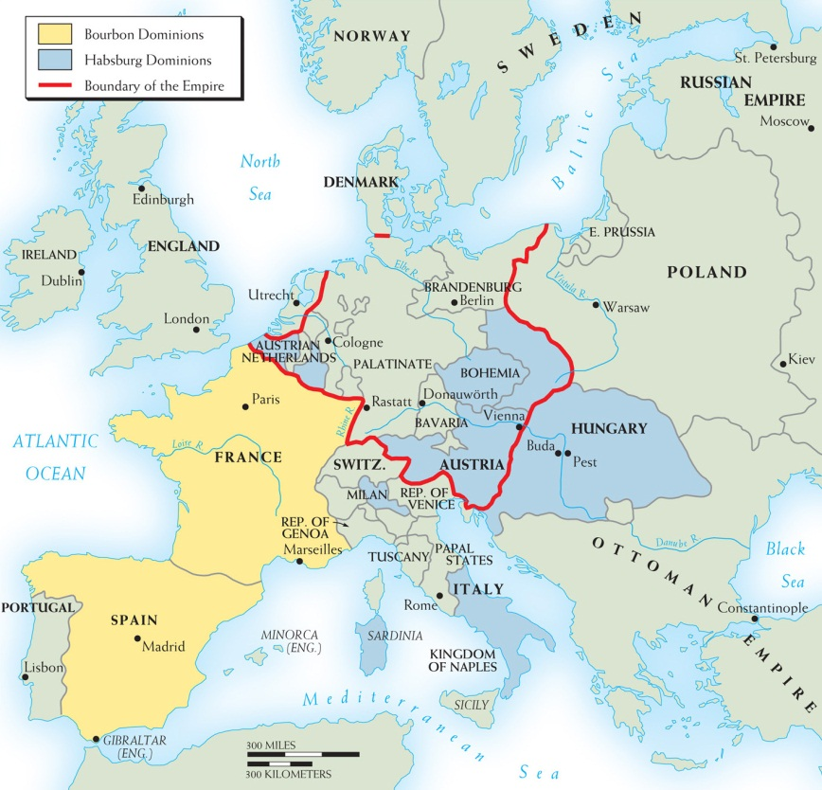

Map 13–2 EUROPE IN 1714 The War of the Spanish Succession ended a year before the death of Louis XIV. The Bourbons had secured the Spanish throne, but Spain had forfeited its possessions in Flanders and Italy.

Section 4 Questions

- How did Louis XIV consolidate his authority and become an absolute monarch?
Debate Over the Origin and Character of Political Authority
- Why might Boussuet have wished to make extravagant claims for absolute royal power?
- How does Boussuet’s argument for absolute royal authority lead also to the need for a single uniform religion in France?
- Why does Locke find an absolute monarch in conflict with his subjects and they with him?
- How do Locke’s views serve to provide a foundation for parliamentary government

Section 5: Central and Eastern Europe

Poland with No Central Authority
- Most Polish monarchs were __________ and tools for foreign powers
- Had a central legislative body called the Sejm or diet, but it had no real power as any single veto, liberum veto, could stop a Sejm
- Poland disappears from map in 18th century as a result

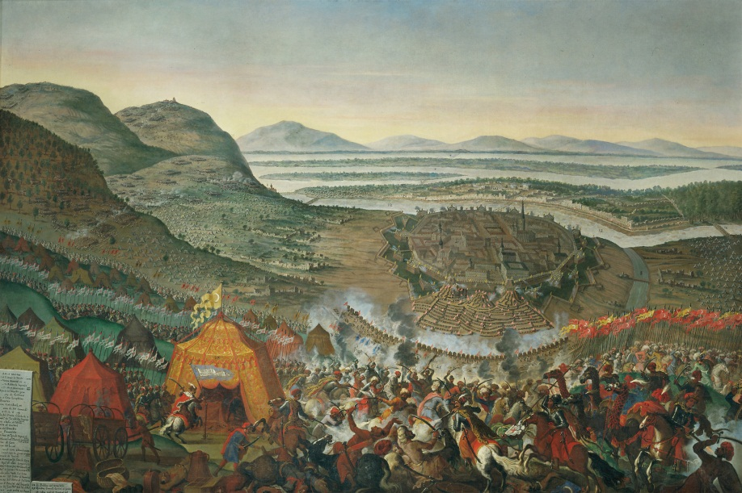

The Hapsburg Empire and the Pragmatic Sanction
- ____________ held onto the title of Holy Roman Emperor, but the title depended on help from many other German states and principalities
- Their territories, some outside of Germany, were so geographically and culturally diverse that there was no real central government
- Despite internal difficulties, the empire increases under Leopold I, Joseph I, and Charles VI
- Pragmatic Sanction – Charles VI’s legal basis for a single line of inheritance within the Hapsburg dynasty, putting his _________ Maria Theresa in charge
- ______________ of Prussia invades Hapsburg Empire and puts Maria at risk in 1740

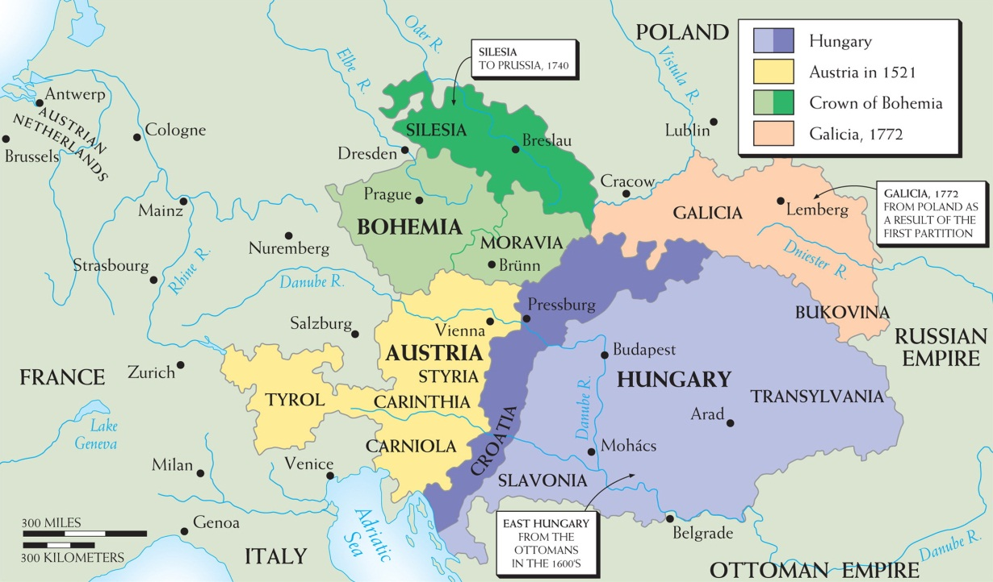
Map 13–3 THE AUSTRIAN HABSBURG EMPIRE, 1521–1772 The empire had three main units—Austria, Bohemia, and Hungary. Expansion was mainly eastward: eastern Hungary from the Ottomans (17th century) and Galicia from Poland (1772). Meantime, Silesia was lost after 1740, but the Habsburgs remained Holy Roman Emperors

Prussia under the Hohenzollern Family

- Rule of Frederick William, the Great Elector
  - Raised taxes through force to build an _______
  - Junkers, the German noble landlords, in return for obedience to Frederick, could enforce ________
  - Army and Elector become powerful allies

Frederick William’s successors
  - His son, William I, helps Hapsburgs in War of Spanish Succession and becomes _______ of Prussia
  - Frederick William I – most successful Prussian leader – made the strongest army in Europe the symbol of power and unity, while staying out of war
  - Frederick II or _______ – did not have wisdom of his father and invaded Silesia, starting long Austrian-Prussian rivalry

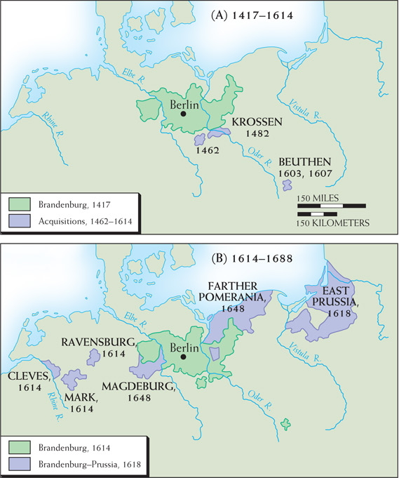

Map 13–4 EXPANSION OF BRANDEBURG-PRUSSIA In the 17th century Brandenburg-Prussia expanded mainly by acquiring dynastic titles in geographically separated lands. In the 18th century it expanded through aggression to the east, seizing Silesia in 1740 and various parts of Poland in 1772, 1793, and 1795.
Section 5 Questions
- What is the Pragmatic Sanction? Did it work? Why or why not?
- How were the Hohenzollerns able to forge their diverse landholdings into the state of Prussia? What role did the Junkers play?

Section 6: Russia – The Romanov Dynasty
- Starting with a seventeen year-old boy Michael and his two successors, Aleksei and Theodore II, brought stability and modest bureaucratic centralization to Russia
- Russia needed this after the reign of Ivan the Terrible

Peter the Great – Early Years
- Came to power at age ten and believed that the power of the tsar must be secure from the jealousy and greed of the boyars, the old nobility, and the streltsy, the guards of the Moscow garrison
  - publicly executed rebellious streltsy and repressed and humiliated the boyars
- Wanted to increase Russian military power, so he __________ an army of 300,000 soldiers
- Built a ___________ on the Baltic Sea and went to war with the ______________
- The Great Northern War – Peter defeats the _____________ and takes control of Estonia, Livonia, parts of Finland
- ______________ – built a capital in honor of himself with places forcibly built by the boyars that resembled small versions of Versailles
- Peter’s son, Aleksei, with Charles VI of Hapsburg, attempts a conspiracy against Peter and is sentenced to death; dies in prison under mysterious circumstances

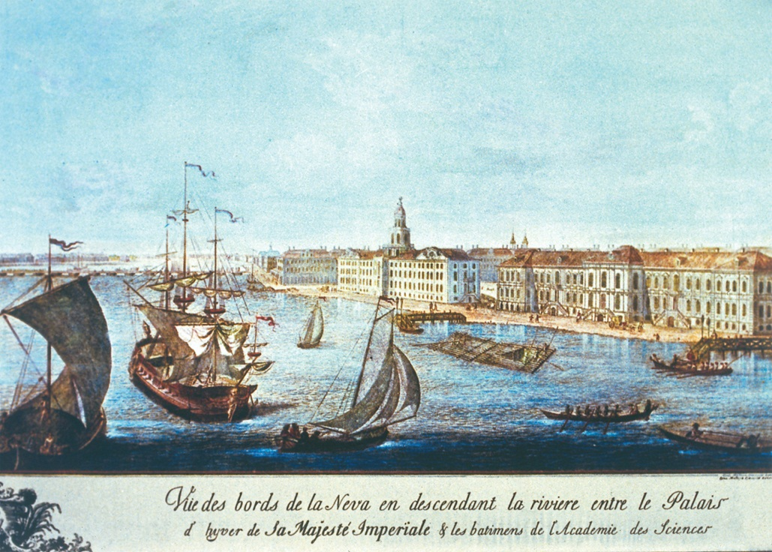

Peter the Great built St. Petersburg on the Gulf of Finland to provide Russia with better contact with western Europe. He moved Russia’s capital there from Moscow in 1712. This is an eighteenth-century view of the city.
The Granger Collection

Peter the Great – Later Years
- Peter realized he was faced with a lot of opposition, so he brings the nobility and the Russian Orthodox Church closer to the tsar
- Table of Ranks – made a person’s social position and privileges more important than lineage
- Abolishes the patriarch and puts in its place the Holy Synod, which consisted of several bishops headed by a layman called the procurator general
- 1725 – Peter dies and leaves no successor as Russia becomes ________
Section 6 Questions
- What domestic and military reforms did Peter the Great institute in Russia?

Vocabulary
Divine Right of Kings Glorious Revolution Parliamentary Monarchy
Fronde Pragmatic Sanction Jansenism Puritans
Junkers political absolutism parlements William III of Orange
Dutch East india Company James I Charles I Long Parliament Oliver Cromwell
Restoration Test Act Rober Walpole Louis IX War of the Spanish Succession Holy Roman Empire Charles VI Fredrick William I Streltsy Peter the Great Boyars Table of Ranks Holy synod

