CHAPTER 7 – SOCIETY AND ECONOMY UNDER THE OLD REGIME IN THE
EIGHTEENTH CENTURY

CHAPTER SUMMARY (For all)

This chapter surveys the life and institutions of eighteenth-century Europe before 1789. They are known as the Old Regime (ancien regime) to separate them from the great innovations that followed the French Revolution. Politically, the term stood for absolute monarchies, large bureaucracies, and armies led by aristocrats. Economically, the Old Regime was marked by a scarcity of food, agrarian economy, slow transport, little iron production, unsophisticated finances, and sometimes commercial overseas empire. The society of pre-revolutionary Europe was traditional and hierarchical. It ranged from governing aristocratic elite to an urban middle class and labor force divided into guilds to a rural peasantry living at the edge of poverty. Society was also corporate and privileged, for men were more conscious of their communal associations and group rights than of individual liberties. The Old Regime was marked by great contrasts between different classes and regions, especially between western Europe and the countries east of the Elbe River. Finally, although the character of the old regime was very distinct, it was not static. Society itself fostered a number of developments that eventually led to change: revolutions in agriculture and industry, the creation of new products and wealth, population expansion, and tension among monarchs, nobles, and the middle class.
The economy of the eighteenth century depended on the land. In the west, most of those who lived in the countryside were free peasants; in the east, most were serfs. The landowners subjected both of these groups to feudal dues, services, and strict control, which often resulted in peasant discontent and rebellion. The most dramatic revolt was Pugachev’s rebellion of 1773–1775, which involved all of southern Russia. One of the clearest examples of aristocratic domination and control was the English game laws. English landowners reserved the exclusive right to hunt game animals for themselves. The game laws are a prime example of legislation designed to maintain economic and social status.
The chapter continues with a study of family structures and the family economy. In preindustrial Europe, the household was the basic unit of production and consumption. In northwestern Europe, the household most was most often made up of a married couple, their children, and few household servants. Children lived in their parents’ households only until their early teens, at which time they entered the work force. Eastern European households were generally larger, consisting of perhaps several generations.
Most family members worked within the family economy to support the household. Women devoted their lives to maintaining either their parents’ household or that of their husbands if they married. As long as they were productive to the household, they could live at home. If a girl’s labor were unneeded on the family farm, she might find employment on another farm, or move to a nearby town or city. The text offers a close study of the various avenues open, and closed, to a woman in preindustrial Europe.
Childbearing and the raising of children were challenging ventures. An increase in illegitimate births and unwanted pregnancies led to infanticide and child abandonment. Foundling hospitals were established to deal with the alarming numbers of abandoned and unwanted children.
The text continues with a treatment of the Agricultural Revolution. A steady rise in the price of Europe’s food staple, grain, because of population growth, encouraged a revolution in agriculture, leading to greater productivity. Famous agricultural innovators included Jethro Tull, Charles Townsend, and Robert Bakewell. The enclosure system was a controversial innovation that commercialized agriculture, leaving peasants at a disadvantage.
Improvements in grain production further spurred population growth: in 1700, the population of Europe had been 100–120 million; by 1800, it was about 190 million; and by 1850, the population had reached approximately 260 million. The population explosion placed new demands and pressures on eighteenth-century society—as did the incipient industrial revolution in the second half of the century that facilitated sustained economic growth that has continued almost without interruption ever since. The Industrial Revolution might also be seen as a revolution in consumption. The desire for consumer goods and a higher standard of living fueled the engines of the Industrial Revolution. New methods of textile production, the invention and the steam engine, and innovations in iron production are each noted in the chapter.
The transformation of agriculture and industry led to changes that diminished the importance and the role of women already in the work force. Women, displaced from farming or spinning thread, turned to cottage industries, and thousands became domestic servants of commercial families. The work and workplaces of men and women were becoming increasingly separate.
Europe’s cities grew considerably during the century, although even in urbanized Britain and France, they seem to have contained less than twenty percent of the population. The cities were not industrial centers, but market towns, commerce and financial centers, or capital cities. A small group of nobles, rich merchants, bankers, financiers, clergy, and officials ruled the cities. Below them was the prosperous middle class (bourgeoisie), a dynamic element increasingly resentful of aristocratic monopoly of power and prestige. The largest and poorest group in the city was made up of shopkeepers, artisans, and wage earners who were generally organized into guilds. Even before the French Revolution, members of this lower class often expressed their political grievances by rioting.
The chapter ends with an evaluation of Jewish life in Europe during the eighteenth century. Jews dwelled in most nations without enjoying the rights and privileges of other subjects. They were regarded as a kind of resident alien whose status might be temporary or changed at the whim of local rulers or the monarchical government. Jews under the Old Regime lived apart from non-Jews in distinct urban districts called ghettos or in Jewish villages in the countryside. Although “court Jews” helped finance the wars of major rulers and received privileges, the vast majority of the Jewish population of Europe lived in poverty. Under the Old Regime, discrimination was not based on race, but on religious separateness. Those Jews who remained loyal to their faith were subject to various religious, civil, and social disabilities. The end of the Old Regime brought major changes in the lives of these Jews and in their relationship to a larger culture.
By the end of the eighteenth century, many of the facets of the Old Regime had been changed in fundamental ways. Europe stood on the brink of a new era.

OUTLINE (use all points that pertain to your topic to guide you in preparation)

I. Major Features of Life in the Old Regime

Read the Document “De Staël on the Ancien Regime (1789)” on MyHistoryLab.com

A. Maintenance of Tradition
B. Hierarchy and Privilege

II. The Aristocracy
- Varieties of Aristocratic Privilege
- Aristocratic Resurgence

Read the Document “Voltaire, on Social Conditions in Eighteenth Century France” on MyHistoryLab.com

III. The Land and its Tillers
- Peasants and Serfs

Read the Document “The Marquis de Mirabeau, The Friend of Men, or Treatise on Population, 1756” on MyHistoryLab.com
View the Map “Russian Serfs” on MyHistoryLab.com

- Aristocratic Domination and the Countryside: The English Game Laws

IV. Family Structures and the Family Economy
A. Households
B. The Family Economy
C. Women and the Family Economy
D. Children and the World of the Family Economy

V. The Revolution in Agriculture
A. New Crops and New Methods

View the Image “Diderot’s Encyclopedia—Plate Illustrating Agricultural Techniques” on MyHistoryLab.com
View the Map “Map Discovery: English Common Lands Enclosed by Acts of Parliament, 1700–1850” on MyHistoryLab.com

B. Expansion of the Population

View the Map “Map Discovery: Population Growth in Europe, 1800–1850” on MyHistoryLab.com

VI. The Industrial Revolution of the Eighteenth Century
A. A Revolution in Consumption
B. Industrial Leadership of Great Britain

View the Map “Map Discovery: Concentrations of Industry in Great Britain, 1750–1820” on MyHistoryLab.com

C. New Methods of Textile Production
D. The Steam Engine

Read the Document “James Watt on Steam Engines (mid to late 1700s)” on MyHistoryLab.com
Read the Document “Richard Guest, The Creation of the Steam Loom” on MyHistoryLab.com

E. Iron Production

View the Architectural Simulation “Cast Iron Construction” on MyHistoryLab.com

F. The Impact of the Agricultural and Industrial Revolutions on Working Women

VII. The Growth of Cities
- Patterns of Preindustrial Urbanization
- Urban Classes

View the Image “Gin Lane, William Hogarth” on MyHistoryLab.com
Read the Document “Jacques-Louis Menetra, Journal of My Life” on MyHistoryLab.com

- The Urban Riot

VIII. The Jewish Population: The Age of the Ghetto

IX. In Perspective

LEARNING OBJECTIVES MUST INCORPORATE THIS AND CHECK IF LEARNING OBJECTIVE FOR YOUR TOPIC IS MET(DISCUSSION QUESTION , SHORT Q&A

How did tradition, hierarchy, and privilege shape life in the Old Regime?

What was the foundation of the wealth and power for the eighteenth-century aristocracy?

How were peasants and serfs tied to the land in eighteenth-century Europe?

What role did the family play in the economy of preindustrial Europe?

What led to the agricultural revolution of the eighteenth century?

Why did the Industrial Revolution begin in Britain?

What problems arose as a result of the growth of cities?

How did the suppression of Jews in European cities lead to the formation of ghettos?

DISCUSSION QUESTIONS

1. What kinds of privileges separated European aristocrats from other social groups? How did their privileges and influence affect other people living in the countryside? What was the condition of serfs in central and eastern Europe?

2. How would you define the term family economy? How did the family economy constrain the lives of women in preindustrial Europe?

3. What caused the Agricultural Revolution? How did the English aristocracy contribute to the Agricultural Revolution? Why did peasants revolt in the eighteenth century?

4. Why did Europe’s population increase in the eighteenth century? How did population growth affect consumption?

5. What was the Industrial Revolution and what caused it? Why did Great Britain take the lead in the Industrial Revolution? How did consumers contribute to the Industrial Revolution?

6. How did the distribution of population in cities and towns change? How did the lifestyle of the upper class compare to that of the middle and lower classes? What were some of the causes of urban riots?

7. Where were the largest Jewish populations in eighteenth-century Europe? What was their social and legal position? What were the sources of prejudices against Jews?

LECTURE TOPICS(Use this in preparing )

1. Family Structure and Family Economy: A section of this chapter focuses on family structure. Most Europeans worked within the context of the family economy. This is to say the household was the fundamental unit of production and consumption. Family members worked together to sustain their economic life because it was almost impossible to support oneself independently. Recent demographic investigation has revealed that the northwestern European household was not extended, but nuclear. Children lived with their parents only until their early teens, when they often moved away and worked in other households as servants. The family economy also established many of the chief constraints on women in pre-industrial society. A woman’s life was devoted to the maintenance of her parent’s household and then to assuring that she would have her own to live in as an adult. Bearing and rearing children were often subordinate to these goals. Children too became part of the family economy; there were many perils of early childhood, but with the seventeenth and early eighteenth centuries came a new interest in preserving the lives of abandoned children with the establishment of foundling hospitals. The chapter also presents a section on the impact of the Agricultural and Industrial Revolutions on working women.

2. The Agricultural Revolution: The chapter emphasizes the importance of the agricultural innovations of this period. Jethro Tull, for example, introduced the iron plough and “Turnip” Townsend introduced the three-field-system of crop rotation. Such innovations required large blocks of land, and landlords enclosed common land throughout the countryside, which brought about social turmoil, but did not depopulate the rural areas as is sometimes claimed.

3. The Industrial Revolution: As in agriculture, Britain took the lead in the industrial revolution, favored as it was by rich deposits of coal and iron ore, a stable political structure, consumer demand from the colonies, a law tax structure, and relative social mobility. The chapter details such innovations as the flying shuttle, spinning-jenny, and water frame in the textile industry and the development of the steam engine. Important as these changes were, their full economic and social ramifications were not really felt until the nineteenth century.

4. The Aristocracy: Before 1789, the aristocracy was still the wealthiest and most influential sector of the population in all countries, although it differed from place to place. Britain’s nobility was Europe’s smallest, wealthiest, and most socially responsible; France’s aristocracy was larger and more complex and benefitted from more legal privileges, especially tax exemption. The chapter discusses in further detail the aristocracies in Poland, Prussia (Junkers), and Russia. Squeezed between absolutist monarchs and the growing commercial classes, Europe’s nobles tried to reassert their power throughout the century, a movement termed the “aristocratic resurgence.”

SUGGESTED FILMS (if possible)

The London of William Hogarth. International Film Bureau. 26 min.

Civilization IX: The Pursuit of Happiness. Time-Life Films. 52 min.

Industrial Revolution in England. Encyclopaedia Britannica. 25 min.

Tom Jones. United Artists. 128 min.

The Mayor of Casterbridge. A&E. 200 min.

Dangerous Liaisons. Warner Home Video. 119 min.

ATLAS OF WESTERN CIVILIZATION

Europe in the Eighteenth Century

ASSET DIRECTORY

Images

During the eighteenth century farm women normally worked in the home and performed such tasks as churning butter as well as caring for children. As time passed tasks such as making butter were mechanized and women were displaced from such work. Page 236

An Aristocratic Couple Portraits, such as this one of the English landowner, Robert Andrews and His Wife, by Thomas Gainsborough (1728–1788), contain many clues to the aristocratic dominance of landed society. page 240

Eighteenth-century France had some of the best roads in the world, but they were often built with forced labor. French peasants were required to work part of each year on such projects. This system, called the corvée, was not abolished until the French Revolution in 1789. Page 242

Emelyan Pugachev (1726–1775) led the largest peasant revolt in Russian history. In this contemporary propaganda picture he is shown in chains. An inscription in Russian and German was printed below the picture decrying the evils of revolution and insurrection. Page 242

During the seventeenth century the French Le Nain brothers painted scenes of French peasant life. Although the images softened many of the harsh realities of peasant existence, the clothing and the interiors were based on actual models and convey the character of the life of better off French peasants whose lives would have continued very much the same into the eighteenth century. Page 245

The English agricultural improver Jethro Tull devised this seed drill, which increased wheat crops by planting seed deep in the soil rather than just casting it randomly on the surface. Page 249

This is the detail of a 1739 map by Louis Bretez, a member of the Academy of Painting and Sculpture, showing an aerial view of the city of Paris. The primary function of the map was to reestablish Paris as the universal model of a capital city. Page 253

Consumption of all forms of consumer goods increased greatly in the eighteenth century. This engraving illustrates a shop, probably in Paris. Here women, working apparently for a woman manager, are making dresses and hats to meet the demands of the fashion trade. As the document on page 503 demonstrates, some women writers urged more such employment opportunities for women. Page 255

James Hargreaves’s Spinning Jenny permitted the spinning of numerous spindles of thread on a single machine. Page 257

Newcomen’s steam engine had a major impact on the growth of industrialization. Page 259

During the eighteenth century, most goods were produced in small workshops, such as this iron forge painted by Joseph Wright of Derby (1734–1797), or in the homes of artisans. Not until very late in the century, with the early stages of industrialization, did a few factories appear. In the small early workshops, it would not have been uncommon for the family of the owner to visit, as portrayed in this painting. Page 260

In the eighteenth century washing linen clothing by hand was a major task of women servants. Page 266

This engraving illustrates a metalworking shop such as might have been found in almost any town of significance in Europe. Most of the people employed in the shop probably belonged to the same family. Note that two women are also working. The wife may very well have been the person in charge of keeping the accounts of the business. The two younger boys might be children of the owner or apprentices in the trade, or both. Page 267

During the Old Regime, European Jews were separated from non-Jews, typically in districts known as ghettos. Relegated to the least desirable section of a city or to rural villages, most lived in poverty. This watercolor painting depicts a street in Kazimlesz, the Jewish quarter of Kraków, Poland. Page 268

Timeline

MAJOR INVENTIONS IN THE TEXTILE-MANUFACTURING REVOLUTION

Documents

MANCHESTER’S CALICO PRINTERS PROTEST THE USE OF NEW MACHINERY

PRISCILLA WAKEFIELD DEMANDS MORE OCCUPATIONS FOR WOMEN

BELORUSSIAN JEWS PETITION CATHERINE THE GREAT

A Closer Look

AN ARISTOCRATIC COUPLE

1) With his dog, rifle, and wife at his sides Andrew stands over his estate as if he owned the whole world. What cares and dangers would a man of his high standing have?

2) Do the darkening clouds in the background suggest that all may not be well?

3 Might the great space the painter has left in Mrs. Andrews’ very thin lap point to an expectant child?

Compare and Connect

TWO EIGHTEENTH-CENTURY WRITERS CONTEMPLATE THE EFFECTS OF DIFFERENT ECONOMIC STRUCTURES

1) Why does Turgot favor those farmers who can make investments in the land they rent from a proprietor?

2) What are the structures of the métayer system? Why did it lead to poor investments and lower harvests?

3) Why does Hume link industry and the arts?

4) How does he see a commercial, improving economy producing important intellectual outlooks and social skills?

5) What benefits to agriculture might Hume have assigned to prosperous cities, and what benefits might Turgot have seen agriculture contributing to urban life?

Encountering the Past

WATER, WASHING, AND BATHING

1) Why did bathing become less frequent after the late Middle Ages?

2) How did the use of linen clothing contribute to this change?

Web Links

Early Factory Legislation
www.parliament.uk/about/living-heritage/transformingsociety/livinglearning/19thcentury/overview/earlyfactorylegislation/
A discussion of early British factory legislation, with links to the text of key bills.

Women in World History Curriculum: Industrial Revolution
www.womeninworldhistory.com/lesson7.html
Sponsored by Women in World History Curriculum, this site details the plight of working women in industrial England.

Child Labour in the 19th Century
www.spartacus.schoolnet.co.uk/IRchild.main.htm
This site chronicles child labor in Britain, including life in the factory and first-hand experiences.

Modern History Sourcebook: Tables Illustrating the Spread of Industrialization
www.fordham.edu/halsall/mod/indrevtabs1.html
Charts and statistics about industrialization in Europe.

Internet Modern History Sourcebook: Industrial Revolution
www.fordham.edu/halsall/mod/modsbook14.html
An outstanding collection of documents on the Industrial Age with links.

MyHistoryLab Media Assignments

Find these resources in the Media Assignments folder for Chapter 7 on MyHistoryLab

QUESTIONS FOR ANALYSIS

1. What are some of the privileges of aristocracy in Europe illustrated by this painting?

Section: The Aristocracy
View the Closer Look An Aristocratic Couple

2. What explains the patterns of greater and lesser concentrations of serfs in Russia in this period?

Section: The Land and Its Tillers
View the Map Russian Serfs

3. What areas seem to have been more immune to enclosure?

Section: The Revolution in Agriculture
View the Map Map Discovery: English Common Lands Enclosed by Acts of Parliament, 1700–1850

4. What were some of the problems James Watt had to overcome to make a useful steam engine?

Section: The Industrial Revolution of the Eighteenth Century
Read the Document James Watt on Steam Engines (mid to late 1700s)

5. What was the role of the church in Menetra’s life?

Section: The Growth of Cities
Read the Document Jacques-Louis Menetra, Journal of My Life

OTHER RESOURCES FROM THIS CHAPTER

Major Features of Life in the Old Regime

Read the Document De Staël on the Ancien Regime (1789)

The Aristocracy

Read the Document Voltaire, on Social Conditions in Eighteenth-Century France

The Land and Its Tillers

Read the Document The Marquis de Mirabeau, The Friend of Men, or Treatise on Population, 1756

The Revolution in Agriculture

View the Image Diderot’s Encyclopedia—Plate Illustrating Agricultural Techniques
View the Map Map Discovery: Population Growth in Europe, 1800–1850
Read the Compare and Connect Two Eighteenth-Century Writers Contemplate the Effects of Different Economic Structures

The Industrial Revolution of the Eighteenth Century

View the Map Map Discovery: Concentrations of Industry in Great Britain, 1750–1820
Read the Document Richard Guest, The Creation of the Steam Loom
View the Architectural Simulation Cast Iron Construction

The Growth of Cities

View the Image Gin Lane, William Hogarth

Format of your Data sheet

- Your Topic
- Learning Objective
- Notes outline (space for students to fill in) (See Notes outline and LECTURE TOPICS)
- Discussion question (s) (Call students to think, respond and write)
- HIPPO one primary or secondary source ( See MYHISTORYLAB media assignment)
- Create one thematic short Q&A ( assign as homework)

You are graded on – (5 points each = 25 points)

- Careful planning (all the above 6 )
- Data sheet ( 1 through 3)
- Presentation with discussion (4)
- Analysis of Primary /Secondary Source with class (5)
- Thematic short Q&A

Sample of writing a thematic short Q&A

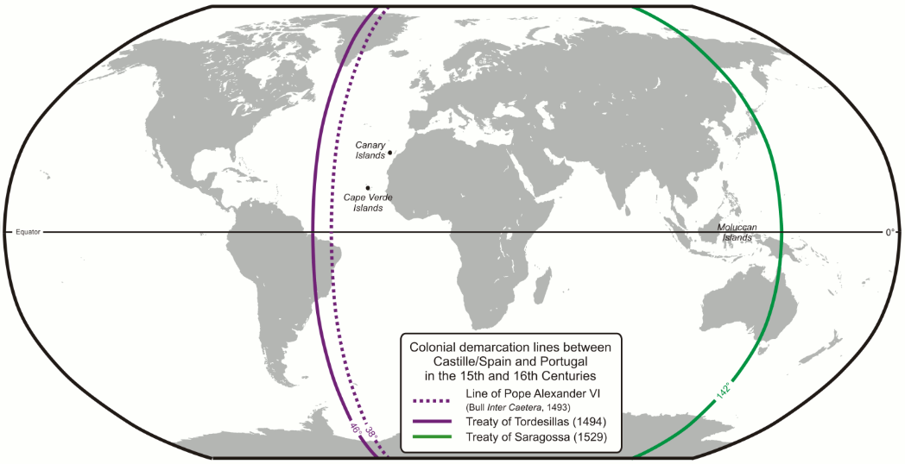
1.) During the Age of Exploration, Spain and Portugal were competing for territories and global trade.

A.) Provide at least ONE specific piece of evidence that demonstrate a similarity in Spanish and Portuguese interests in the New World
B.) Provide at least TWO specific pieces of evidence that demonstrate differences between Spanish and Portuguese experiences in the New World

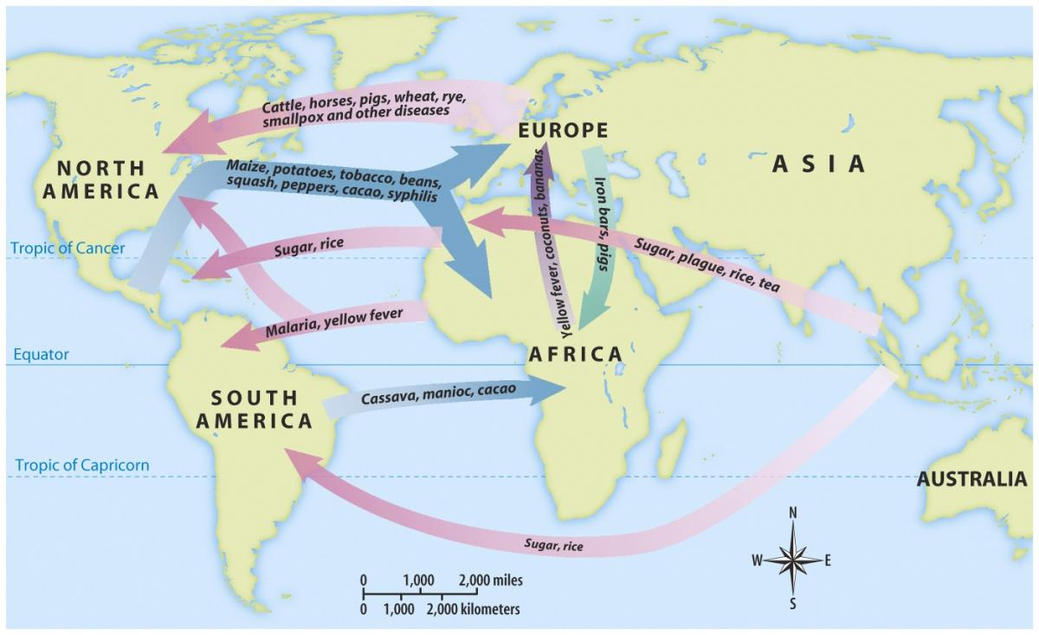

2) The Columbian Exchange

A.) Explain TWO specific ways that the Columbian Exchange broke from previous economic practices after the discovery of the New World
B.) Explain ONE specific way that the Columbian Exchange continued economic practices after the discovery of the New World

Christopher Columbus reports on his first voyage to Queen Isabella 1493
In the island, which I have said before was called Hispana, there are very lofty and beautiful mountains, great farms, groves and fields, most fertile both for cultivation and for pasturage, and well adapted for constructing buildings. The convenience of the harbors in this island, and the excellence of the rivers, in volume and salubrity, surpass human belief, unless on should see them. In it the trees, pasture-lands and fruits different much from those of Juana. Besides, this Hispana abounds in various kinds of species, gold and metals. The inhabitants . . . are all, as I said before, unprovided with any sort of iron, and they are destitute of arms, which are entirely unknown to them, and for which they are not adapted; not on account of any bodily deformity, for they are well made, but because they are timid and full of terror. . . . But when they see that they are safe, and all fear is banished, they are very guileless and honest, and very liberal of all they have. No one refuses the asker anything that he possesses; on the contrary they themselves invite us to ask for it. They manifest the greatest affection towards all of us, exchanging valuable things for trifles, content with the very least thing or nothing at all. . . . I gave them many beautiful and pleasing things, which I had brought with me, for no return whatever, in order to win their affection, and that they might become Christians and inclined to love our King and Queen and Princes and all the people of Spain; and that they might be eager to search for and gather and give to us what they abound in and we greatly need.

3. Based on the quote and your understanding of European History, please answer the following:

A. Explain TWO specific ways Columbus’s interactions set a precedent for future European interactions with the Indigenous populations of the New World
B. Explain ONE specific way Columbus’s report to Queen Isabella is a misinterpretation or misrepresentation of his interactions with the Natives.

