Class Activity –Enlightenment

Students in groups of 3 will work on creating a colorful high graphic visual mind web ( you may doodle to express your POV for the topic you are working). Each group creates a postcard of a specific Philosophes.
How to Mind Map

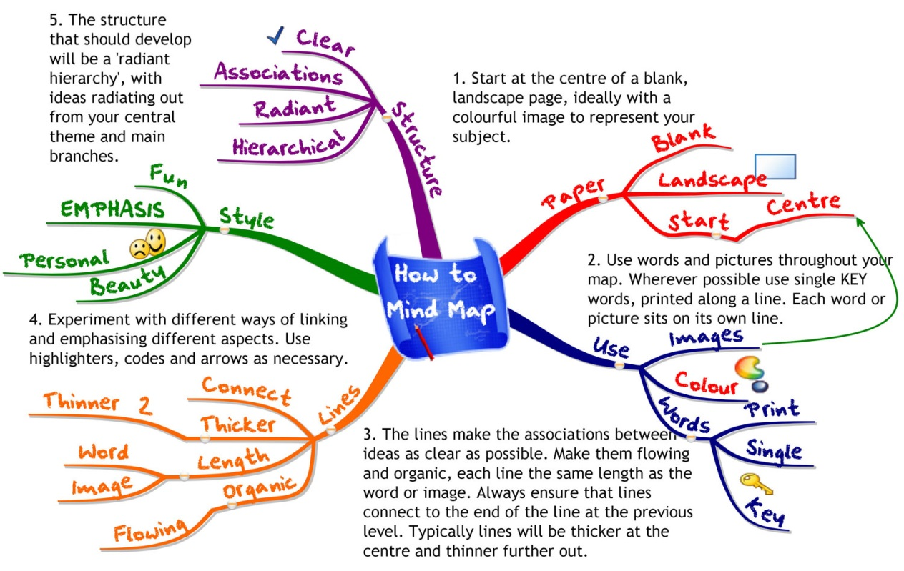
Post card example

Topics
- Adam Smith-His ideas, work, impact then (18th century) and now (21st century).
- Montesquieu His ideas, work, and impact then (18th century) and now (21st century).And INCLUDE view on women
- Rousseau -His ideas, work and impact then (18th century) and now (21st century). And INCLUDE view of women
- Enlightenment and Women –Role of women –Philosophes ideas about role of women
- Voltaire -His ideas, work and impact then (18th century) and now (21st century). And INCLUDE view of women

- Mary Wolstencraft – Her ideas work and impact, INCLUDE her view on Rousseau/Montesquieu
- Thomas Hobbs - His ideas, work, impact then (18th century) and now (21st century).
- Johne Locke- His ideas, work, impact then (18th century) and now (21st century).
- Frederic the Great of Prussia – Political, economic, Social and Religious Reforms . Specify or Highlight Enlightenment Influences if any
- Joseph II of Austria-– Political, economic, Social and Religious Reforms . . Specify or Highlight Enlightenment Influences if any
- Catherine the Great of Russia –Political , economic, Social and Religious Reforms. . Specify or Highlight Enlightenment Influences if any

Topic number | Students Period 3 | Students Period 5 | Post card (requires research)
1 | Ian and Emily | Faith, Oscar | Bacon
2 | Edward, Losa | Toni, Marisol | Diderot
3 | Viviana, Desiree, | Omar, Chris, | Wollstonecraft
4 | Savannah ,Andra | Vanessa ,Devin | Hume
5 | Arleen, Emilia | Idalia, Dylan | Kant
6 | Jesus ,Brandon | Eduardo, Amber | Montesquieu
7 | Gil, Chris, | Jazmin, Natassja | Voltaire
8 | Adrian, Anthony | Natalie, Ethan, | Hobbs
9 | Jocelyn, Adryana, | Julio, Haila | Rousseau
10 | Aeron, , Tabi | Manuel, Aranza | Smith
11 | Marco, Samantha | Roberto, Israel | Locke

