In this lesson, we'll discuss the Commercial Revolution sparked by Europe's interaction with the New World colonies. We'll learn about how mercantilism, banking and joint-stock companies transformed the economic face of the European continent.

Introduction to Commercial Revolution
The Commercial Revolution was a period of European economic expansion, which began in the 16th century. The catalyst for this expansion was Europe's discovery and colonization of the Americas. As trade routes grew between the New World colonies and Old World Europe, the European continent was transformed. Although there were many factors that led to this, today we're going to highlight mercantilism, banking and joint-stock companies.

Mercantilism
Mercantilism is an economic system used to unify and increase the power and monetary wealth of a country by strict government regulation of trade and foreign trading monopolies. Under this system, colonies existed merely for the benefit of their mother country. Like a young girl forced to fork over her babysitting money to her parents, all wealth accumulated by a colony went to its European parent.
Also under mercantilism, colonies were only allowed to import from or export to the European country that governed them. For instance, if Jamestown, governed by England, wanted to import wool from the Dutch, they could not. Even if the Dutch price was substantially cheaper, Jamestown was stuck buying wool from England. Further hamstringing the Jamestown colonists, all the goods produced by the colonies went to England. England then sold the goods to other countries at a substantial markup, which the crown, not the colonists, kept! In other words, the colonies did the work, while England reaped the profit.

Industry and Population Growth
First, the Commercial Revolution changed Europe from a local economy to a global one. Before the revolution, most goods were produced for family use or to be sold within local towns and villages. Other than a few traveling merchants, there was really no way to peddle goods to a larger population. However, once trade routes blossomed between European countries and their colonies, a whole new market opened up. Realizing there was money to be made, people began producing goods to be sold outside of their small communities. In other words, the incentive for profit replaced simply producing for survival.
These new markets and their high demand for goods led to large businesses replacing individual production of goods. As money poured in from this new global trade, Europe continued to transform. The Commercial Revolution also caused a population explosion. Simply put, as wealth flooded the continent, it allowed for larger families. In turn, these larger families created a work force to sustain and grow Europe's new global economy. Of course, as these new markets opened up, European business owners needed a way to deal with all their money! This brings us to the formation of banks and joint-stock companies.

Banks and Joint-Stock Companies
The Commercial Revolution created the need for more banks within Europe. These banks provided money-lending services to parties interested in getting in on the blossoming trade. They also began issuing bills of exchange. These worked like our modern-day checking accounts. Rather than lugging around piles of gold, banks allowed merchants to deposit their earnings and receive a bill of exchange. Merchants could then turn these documents in when they needed to withdraw their gold. Not only was this more convenient, it was much safer than carrying gold along trade routes.
Along with banks, the Commercial Revolution saw the creation of joint-stock companies. A joint-stock company is a business owned by shareholders. Each shareholder owns a part of the company determined by the amount of their initial investment. Since most individual Europeans didn't have the capital needed to launch large trading ventures, joint-stock companies were used to raise capital for larger projects. This also made starting a business less risky! An excellent example of this was England's East India Company, a joint-stock company that monopolized England's trade with the East Indies. Yes, the investors had to share their d to share their profits, but they also got to spread out their losses!

Inflation
Spain legally amassed approximately 180 tons of gold and 8200 tons of silver through its endeavors in the Americas, and another unknown amount through smuggling, spending this money to finance wars and the arts. The spent silver, suddenly being spread throughout a previously cash starved Europe, caused widespread inflation. The inflation was worsened by a growing population but a static production level, low employee salaries and a rising cost of living. This problem, combined with underpopulation (caused by the Black Death), affected the system of agriculture. The landholding aristocracy suffered under the inflation, since they depended on paying small, fixed wages to peasant tenants that were becoming able to demand higher wages. The aristocracy made failed attempts to counteract this situation by creating short-term leases of their lands to allow periodic revaluation of rent. The manorial system (manor system of lord and peasant tenant) eventually vanished, and the landholding aristocrats were forced to sell pieces of their land in order to maintain their style of living. Such sales attracted the rich bourgeois (from the French word referring to this dominant class, emerging with commerce), who wanted to buy land and thereby increase their social status. Former "common lands" were fenced by the landed bourgeois, a process known as "enclosure" which increased the efficiency of raising livestock (mainly sheep's wool for the textile industry). This "enclosure" forced the peasants out of rural areas and into the cities, resulting in urbanization and eventually the industrial revolution.
On the other hand, the increase in the availability of silver coin allowed for commerce to expand in numerous ways. Inflation was not all bad.

The Price Revolution

Price Revolution: rapid rise in the price of goods in Western Europe, most notably in the period from c. 1500 to 1650

Causes of the Price Revolution

✓ Increase in the production of native silver bullion in Europe in the latter part of the Middle Ages

✓ Vast influx of gold and silver bullion to Europe from Latin America (ex. from what is today Mexico & Bolivia) by the Spanish “Treasure Fleet”

✓ Growth in population led to a rise in demand for goods

✓ Shortage of goods contributed to a rise in prices • results

✓ led to an inflation where the price of goods rose approximately six-fold in 150 years

✓ Many merchants took out loans knowing that it would be easier to pay-off in light of the inflationary economic climate ✓ inflation contributed to economic instability and a shortage of goods, especially in Spain and the Italian states

Colonialism
Mercantilism was a significant driver of Colonialism, as, according to the theory, the colony existed for the benefit of the mother country. This assumption meant that colonies were prohibited from engaging in their own independent commerce, and therefore competing with the mother country. Colonies were established to provide customers, raw materials, and investment opportunities. Other important goals of colonialism were European political considerations, and religious fervor. The administration of the colonies established by the Europeans mirrored in some part the mother country. Spain's encomienda system of forced labor in Latin America and the Philippines was an extension of the Spanish feudal system, with the granting of territory as part of a royal extension of power. After the Spanish acquisition of the Philippines, the pace of exchange between China and the West accelerated dramatically. Manila galleons brought in far more silver to China than the Silk Road. The Qing government attempted to limit contact with the outside world to a minimum. The Qing only allowed trade through the port of Canton,] what is now Guangzhou. Severe red-tape and licensed monopolies were set up to restrict the flow of trade, resulting in high retail prices for imported goods and limited demand. Spain began to sell opium, along with New World products such as tobacco and maize, to the Chinese in order to prevent a trade deficit.
The English, for their part, used the British East India Company as an agent of the crown, which was expected to govern and protect the people and commerce of the colony. The English also developed a commercial empire in North America, India, and Australia, creating colonies, with the intention of making a profit.
As a result of high demand for tea, silk, and porcelain in Britain and the low demand for British commodities in China, Britain had a large trade deficit with China and had to pay for these goods with silver. Britain began illegally exporting opium to China from British India in the 18th century to counter its deficit. The opium trade took off rapidly, and the flow of silver began to reverse. The Yongzheng Emperor prohibited the sale and smoking of opium in 1729 because of the large number of addicts.
The French followed the English to the New World, and settled Quebec in 1608. They did not populate North America as much as the English did, as they did not allow the Huguenots to travel to the New World. In addition, the heavy governmental regulations placed on trade in France discouraged settlement.
The Portuguese Empire was created through commerce bases in South America, Africa, India, and across Southeast Asia.

Law
Laws began to change to deal with commerce, both internationally, and locally within individual countries.
In France, for example, the Ordinance of Marine of Louis XIV was published under the auspices of Colbert in 1691, and was the first complete code of maritime and commercial law; and "when we consider the originality and extent of the design and the ability with which it is executed, we shall not hesitate to admit that it deserves to be ranked among the noblest works that legislative genius and learning have ever accomplished."
In England, the Navigation Acts were among the British effort to regulate trade.

Effects of Commercial Revolution
The Commercial Revolution, coupled with other changes in the Early Modern Period, had dramatic effects on the globe. Christopher Columbus and the conquistadors, through their travels, were indirectly responsible for the massive depopulation of South America. They were directly responsible for destroying the civilizations of the Inca, Aztec, and Maya in their quest to build the Spanish Empire. Other Europeans similarly affected the peoples of North America as well.
An equally important consequence of the Commercial Revolution was the Columbian Exchange. Plants and animals moved throughout the world due to human movements. For example, Yellow fever, previously unknown in North and South America, was imported through water that ships took on in Africa. Cocoa (chocolate), coffee, maize, cassava, and potatoes moved from one hemisphere to the other.
For more than 2000 years, the Mediterranean Sea had been the focus of European trade with other parts of the world. After 1492, this focus shifted to the Atlantic Ocean by routes south around the Cape of Good Hope, and by trans-Atlantic trade.
Another important change was the increase in population. Better food and more wealth allowed for larger families. The migration of peoples from Europe to the Americas allowed for European populations to increase as well. Population growth provided the expanding labor force needed for industrialization.
Another important outcome of Europe's commercial revolution was a foundation of wealth needed for the industrial revolution. Economic prosperity financed new forms of cultural expression during this period.
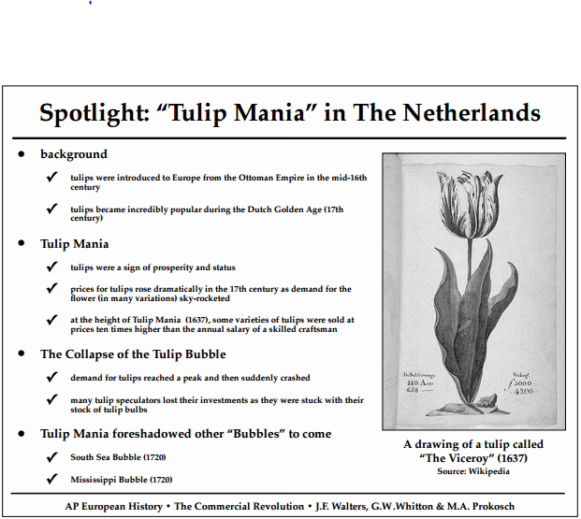

Assignment:
1. How did developments in the late Middle Ages impact the Commercial Revolution?
2. What contribution did Luca Pacioli make to the Commercial Revolution? (need you to research)
3. What was the nature of banking in the Commercial Revolution?
4. What was a joint-stock company?
5. What was the Domestic System in England? (need you to research)
6. What was the Price Revolution and what were its results?
7. What were the principles of mercantilism and what impact did it have on economics and politics?
8. In what ways did the Commercial Revolution sow the seeds of capitalism?
9. What was “Tulip Mania” in the Netherlands?

