The Four Horsemen

Document

1.1

From the Book of Revelation, Chapter 6 (KJV)
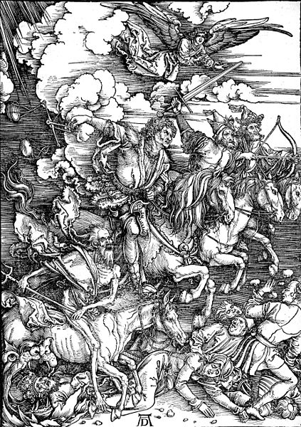
¹And I saw when the Lamb opened one of the seals, and I heard, as it were the noise of thunder, one of the four beasts saying, Come and see.
²And I saw, and behold a white horse: and he that sat on him had a bow; and a crown was given unto him: and he went forth conquering, and to conquer.
³And when he had opened the second seal, I heard the second beast say, Come and see.
⁴And there went out another horse that was red: and power was given to him that sat thereon to take peace from the earth, and that they should kill one another: and there was given unto him a great sword.
⁵And when he had opened the third seal, I heard the third beast say, Come and see. And I beheld, and lo a black horse; and he that sat on him had a pair of balances in his hand.
The Horsemen of the Apocalypse, depicted in a woodcut by Albrecht Dürer (ca. 1497–98)
⁶And I heard a voice in the midst of the four beasts say, A measure of wheat for a [day’s wages], and three measures of barley for a [day’s wages]; and see thou hurt not the oil and the wine.
⁷And when he had opened the fourth seal, I heard the voice of the fourth beast say, Come and see.
⁸And I looked, and behold a pale horse: and his name that sat on him was Death, and Hell followed with him. And power was given unto them over the fourth part of the earth, to kill with sword, and with hunger, and with death, and with the beasts of the earth.

Questions to Consider:

- Who were the Four Horsemen? What did each horse symbolize?

- Why would this passage have been so popular in the fourteenth century? What historical developments convinced Europeans that they were experiencing the Apocalypse? (List as many as you can from the notes that you took over the summer)

Horse #1  My Group’s answer  Teacher’s answer  Events of 14th Century | Horse #2  My Group’s answer  Teacher’s answer  Events of 14th Century
Horse #3  My Group’s answer  Teacher’s answer  Events of 14th Century | Horse #4  My Group’s answer  Teacher’s answer  Events of 14th Century
Horse #1  My Group’s answer  Teacher’s answer: Pestilence  Events of 14th Century  1.1347-48 Black Death  2. 1318 – Sheep infection  3. Periodic return of Plague in summer months | Horse #2  My Group’s answer  Teacher’s answer: War and Unrest  Events of 14th Century  1. 100 years war 1337-1453  2. Civil wars  England – War of the Roses -1485  Wat Tyler & Peasan’ts Revolt 1381  France – Jacques Bonhomme Jacquerie 1358  3.Unemployment encouraged people to turn to crime - attacks on nobles  4. Statute of Labourers 1351 – cut wages  4. Fur Collar Crime  5. Challenges to the Church  Babylonian Captivity & Great Schism  William of Occam  Marsigilio of Padua  England - John Wyclif  Prague - Jan Hus  Lay Piety ( Confraternities) and Mysticism  Holland – The Bretheran Thomas a Kempis  Bridget of Sweden  6. Ethnic tensions - Jews attacked  - Statute of Kilkenny 1366  (forbade marriage between English & Irish)  7. Marital patterns led to Prostitution/Rape/Homosexuality “crimes against nature”  8. Stronger gender divisions – Guilds were increasingly male
Horse #3  My Group’s answer  Teacher’s answer: Famine  Events of 14th Century  1. 1300 – Climate change “Little Ice Age”  Unusual number of storms ruined crops -> starvation  2. Great Famine 1315-1322  3. Prices rose even in non-famine years so fewer people could afford to buy food  4. Reduced caloric intake = susceptibility to disease  5. Workers on reduced diets has less energy = less production  6. People lost homes – deserted villages -> vagabonds | Horse #4  My Group’s answer  Teacher’s answer: Deaths ( pop decline)  Events of 14th Century  1. Deaths through famine and starvation  2. Disease – e.g. Black death  3. Postponement of marriage led to reduced pop as fewer babies born.  4. Animals impacted also 1318 sheep infection – led to sharp decline of wool exports – weavers out of work.

about a litre

