Essay questions Asia 1900-Present
Read chapter 23 from the PDF file (Period 5 reading Ch21-25 Regional)

- Compare and contrast the causes and effects of the Cold War struggle into of the following areas-
- Korea
- Vietnam
- China

(A good response should take up the involvement of the United States and the Soviet Union. It should make clear the ideology could battle between capitalism and communism. However, to resist the urge to place the desires of the United States and the Soviet Union as the primary factor. The various local interests, which shaped the beginnings and ends of each conflict, should be clearly explained.)
Rubric
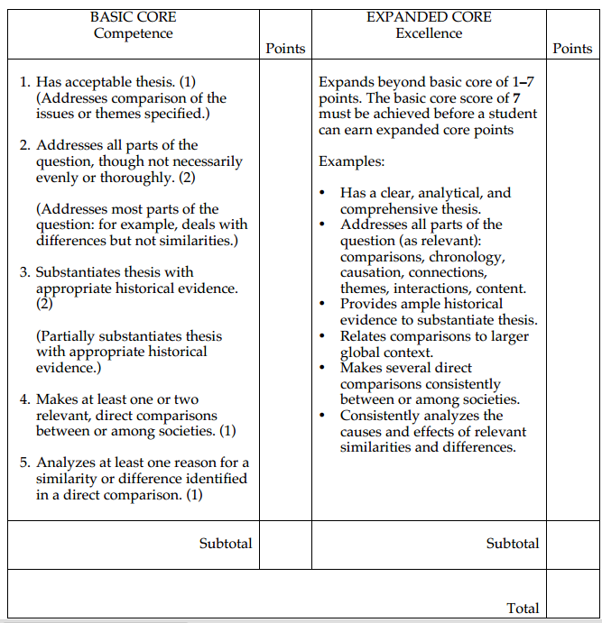

- Discuss the political changes and continuities experienced in ONE of the following nations between World War 1 and World War 2.
- India
- China
- Japan

(A three nations had very different experiences during the 20th century. Japan and China overlap and directly relate to each another. Nonetheless, all three regions faced various degrees of foreign involvement and colonization. A good response will illustrate this struggle, as well as the role played by the two world wars and the Cold War. It should also describe the economic growth that has positioned all three nations on the cusp of global power.)

Rubric
