Essay Questions
1. Compare and contrast the struggle for independence in TWO of the following nations.
- Algeria
- Ghana
- Kenya
- South Africa

(Five key factors explain the independence struggle throughout Africa – World War II, the role of Western educated African elites, the independence of India, Pan-Africanism, and the weakening of Europe as a result of the two world wars. A good response should compare/contrast at least two of the factors. You must also be acutely aware of the role of white settler populations and their effect on the independence struggle. For example, both Kwame Nkrumah of Ghana and Jomo Kenyatta of Kenya studied abroad, in the United States and Great Britain respectively. There they witnessed the hypocrisy of Weston democratic ideals while absorbing notions of black pride and pan – Africanism. South Africa, Algeria, and Kenya were all areas with significant population of white settlers. Whereas Africans in some places were eventually able to negotiate freedom after the success of Indian independence, the settlers fiercely resisted majority ruled. Thus, Africans in Algeria, Kenya, and South Africa were forced to use armed struggle in order to gain independence.)

Rubric
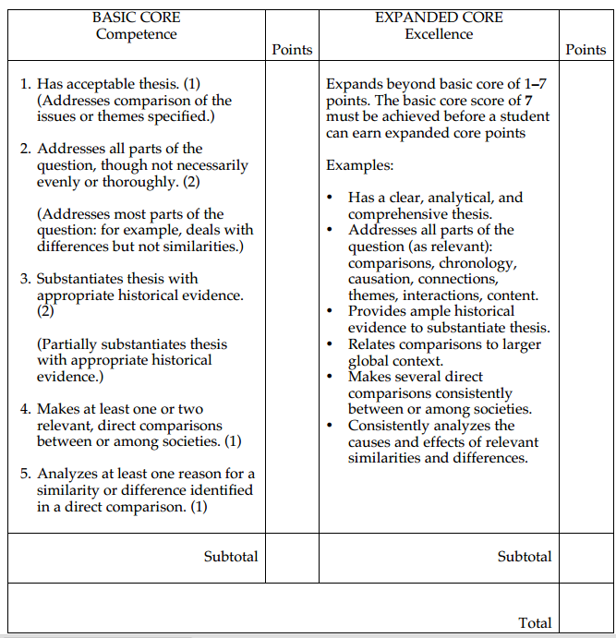
2. Focusing on one of the following factors, discuss the changes in continuities experienced in sub-Saharan Africa from 1914 to the present
- social
- economic
- political
(A good response should begin with a thorough discussion of colonization. Politically, Africans were subject to laws imposed upon them by European nations. They were economically stripped of their resources for the benefits of the European colonizer. Socially, Africans were relegated to second class citizenship in their own land. The struggle for independence marks a clear change as Africans in various nations began to organize resistance movements in order to fight for social, economic, and political power. During the 1940s and 1950s Africans formed stronger bonds across national and continental boundaries in an effort to fight imperialism. The nonalignment movement that sprang out of the band and conference was a key turning point in the Africans' struggle. When African nations gained political independence between the 1950s and the 1980s, they faced the daunting task of trying to define their own destiny despite being mired in the Cold War conflicts of the United States and the Soviet Union. The post – Cold War era has been marked by an effort to gain economic independence. Many foreign companies, especially those from the former colonial powers as well as the United States, maintain control of major industries within African nations. Nonetheless, drought, famine, and political instability have hampered efforts at reducing poverty. International organizations like the World Bank and IMF have offered aid, but often on condition that donees cut subsidy and social programs. Poverty throughout sub-Saharan Africa, therefore, has led many people to migrate to Western European nations as well as the United States. You must decide how best to create your beginning, middle, and end time periods during a century of vast changes. Colonization, decolonization/Cold War, and the post-Cold War era from a good framework for continuity and change over time in Africa.)
Rubric
