Essay questions Middle East 1900-Present
Read chapter 22 from the PDF file (Period 5 reading Ch21-25 Regional)

- Compared and contrast the causes and effects of the 20th century Islamic revolutions in Iran and Afghanistan.

(A good response should discuss the Cold War strategic importance of both nations – both were located on the border of the Soviet Union. Both the United States and Soviet Union were attempting to gain influence in analyze. Your response should also mention that he ran became an American war and Afghans to stand Soviet war. The United States resorted to convert involvement while the Soviets involvement was more direct. In regard to effects, you should mention that both nations shunned westernized nation for conservative Islam. You should also make clear that while the outcomes for both the United States and the Soviet Union would be considered failures, the Soviet Union suffered greater loss because of their greater sense of urgency and involvement.)

Rubric

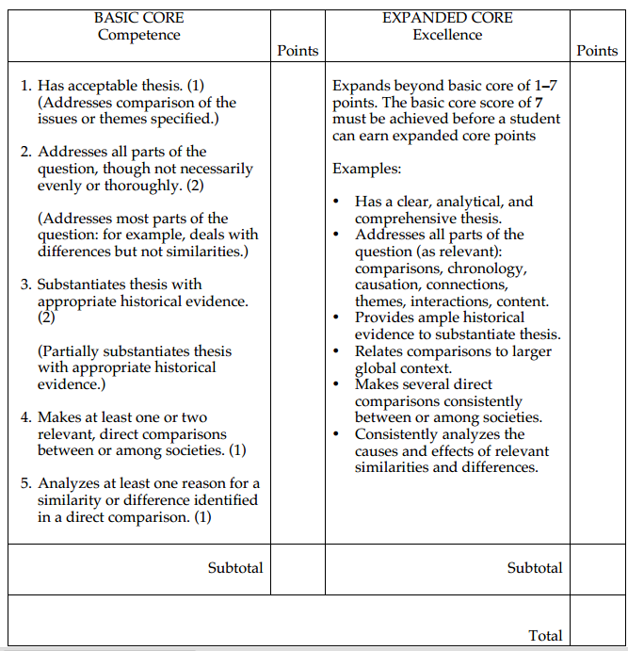
2. Discuss the change and continuity is in the political structure of one of the following Middle Eastern nations during the 20th century.
Egypt
Turkey
Palestine
Iraq
(A good response would include a discussion about colonization (and/or the mandate system), involvement in the Palestine – Israel situation, independence, rising oil wealth, and contemporary issues of terrorism. You should connect colonialism and imperialism to the push for the removal of foreign influence. Be sure to address the tension between modernization, westernized nation, and conservative Islam)

Rubric
