French Revolution DBQ
2015/2016
Directions: The following question is based on the accompanying Documents 1-6. The documents have been edited for the purpose of this exercise. This question is designed to test your ability to apply several historical thinking skills simultaneously, including historical argumentation, use of relevant historical evidence, contextualization, and synthesis. Your response should be based on your analysis of the documents and your knowledge of the topic.
Write a well-integrated essay that does the following:
- States an appropriate theses that directly addresses all parts of the question
- Supports the thesis or an appropriate argument with evidence from all or all but one of the documents AND your knowledge of European history beyond/outside the documents.
- Analyzes a majority of the documents in terms of such features as their intended audience, purpose, point of view, format, argument, limitations, and/or social context as appropriate to the argument
- Places the argument in the context of broader regional, national, or global processes

Question: Using the documents, analyze the extent to which, and the ways in which Enlightenment ideals were applied in the French Revolution.

(periodization)

Document 1
Source: Jean Jacques Rousseau, Swiss Enlightenment philosopher widely recognized for his intellect, The Social Contract, 1762.
Man is born free, and everywhere is in chains. Many a man believes himself to be the master of others who is, no less than they, a slave….
....so far from destroying natural equality, the primitive compact substitutes for it a moral and legal equality which compensates for all those physical inequalities from which men suffer. However unequal they may be in bodily strength or in intellectual gifts, they become equal in the eyes of the law, and as a result of the compact into which they have entered.

Document 2
Source: Francois-Marie Arouet (Votaire), French Enlightenment philosopher who had been repeatedly imprisoned and then exiled for his beliefs about religion, A Treatise on Toleration, 1763.

It does not require great art, or magnificently trained eloquence, to prove that Christians should tolerate each other. I, however, am going further: I say that we should regard all men as brothers. What? The Turk my brother? The Chinaman my brother? The Jew? The Siam? Yes, without doubt; are we not all children of the same father and creatures of the same God?

But these people despise us; they treat us as idolaters! Very well! I will tell them that they are grievously wrong.

Document 3
Source: Cesare Beccaria, Italian criminologist, jurist, philosopher, and politician, On Crimes and Punishment, 1764.
There are only two possible motives for believing that the death of a citizen is necessary. The first: when it is evident that even if deprived of liberty he still has connections and power such as endanger the security of the nation….I see no necessity for destroying a citizen, except if his death were the only real way of restraining others from committing crimes; this is the second motive for believing that the death penalty may be just and necessary….
….It is not the terrible yet momentary spectacle of the death of a wretch, but the long and painful example of a man deprived of liberty…which is the strongest curb against crimes…
For a punishment to be just it should consist of only such gradations of intensity as suffice to deter men from committing crimes. Now, the person does not exist who, reflecting upon it, could choose for himself total and perpetual loss of personal liberty…Many men are able to look calmly and with firmness upon death…

Document 4
Source: The National Assembly, Declaration of the Rights of Man, 1789.
The representatives of the French people, organized as a National Assembly, believing that the ignorance, neglect, or contempt of the rights of man are the sole cause of public calamities and of the corruption of governments, have determined to set forth in a solemn declaration the natural, inalienable, and sacred rights of man,…
1. Men are born and remain free and equal in rights. Social distinctions may be founded only upon the general good.
4. Liberty consists in the freedom to do everything which injures no one else; hence the exercise of natural rights of each man has no limits….These limits can only be determined by law.
8. The law shall provide for such punishments as are strictly and obviously necessary…
10. No one shall be disquieted on account of his opinions, including his religious views…

Document 5
Source: Revolutionary poster, “Unity, Indivisibility of the Republic, Liberty, Equality, Fraternity, or Death,” 1794.
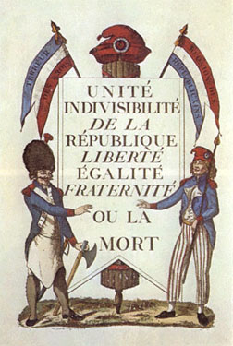

Document 6
Source: Republican Calendar, 1794.
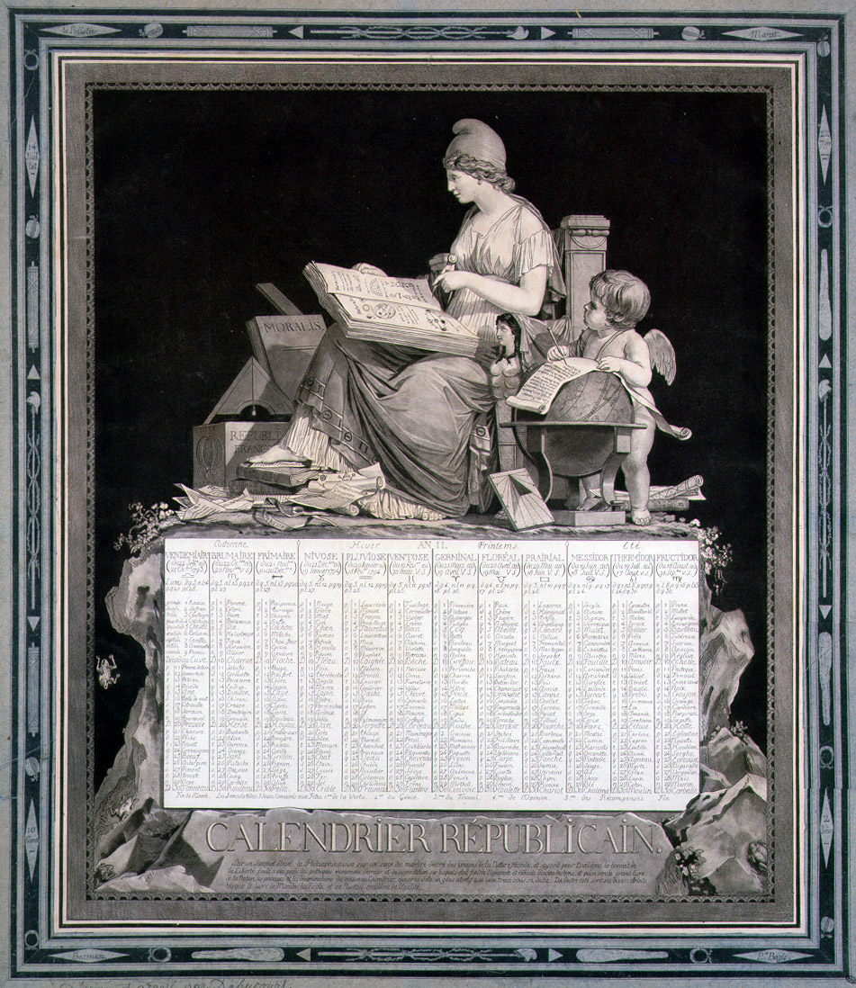

Document 7
Source: Maximilien Robespierre, Speech to the Convention, “The Political Philosophy of Terror,” February 5, 1794.
Since the soul of the Republic is virtue, equality, and since your goal is to found, to consolidate the Republic, it follows that the first rule of your political conduct ought to be to relate all your efforts to maintaining equality and developing virtue….
We must smother the internal and external enemies of the Republic or perish with them. Now, in this situation, the first maxim of your policy ought to be to lead the people by reason and the people’s enemies by terror….Terror is nothing but prompt, severe, inflexible justice; it is therefore an emanation of virtue….
…Subdue liberty’s enemies by terror, and you will be right, as founders of the Republic…

