Chapter 9: Industrial Revolution Exam Version B

1.
Which of the following reasons allowed England to lead the Industrial Revolution?
A | agricultural revolution |  | C | abundance of skilled labor
B | colonialism |  | D | strong government regulation

2.
Which of the following was the MOST advanced power source during the Industrial Revolution?
A | nuclear power |  | B | animal power |  | C | water power |  | D | steam power

3.
Which one of Thomas Edison's inventions allowed factories to operate 24 hours a day?
A | steam engine |  | B | Bessemer process |  | C | light bulb |  | D | spinning Jenny

4.
__________ created the cotton gin making it easier to clean cotton, resulting in increased cotton production.
A | Eli Whitney |  | B | James Hargreaves |  | C | James Watt |  | D | Edmund Cartwright

5.
The Industrial Revolution concentrated workers into mills, factories and mines and their families into rapidly growing cities. Often, due to overpopulation and low wages, starvation was a real possibility. What was something the workers did to improve their situation?
A | They planted vegetable gardens to get more food.
B | They formed labor unions to bargain with employers.
C | They sent petitions to the King.
D | They formed new political parties.  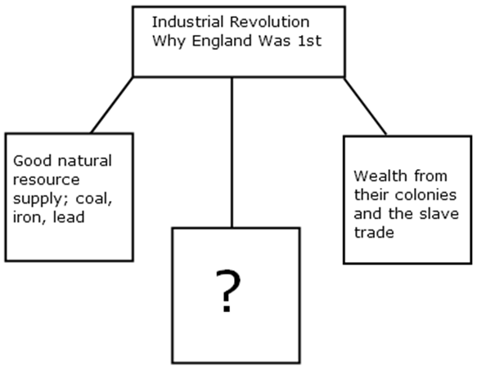  6. The diagram above gives reasons why England was the first nation to industrialize during the Industrial Revolution Era. Which of the following answers would best fit the empty box above?  A had many universities that encouraged advanced thinking  B had a large population and a ready labor source  C society was heavily regulated by the government  D they isolated themselves from the thinking of other nations

7.
Life span was shorter for those living in the city compared to those in the country during the Industrial Revolution. Which factor contributed the MOST to this problem?
A | 14 hour work days |  | C | disease caused by unhealthy living conditions
B | low income housing |  | D | lack of health care

8.
Which of the following is a long term result of Europe's Industrial Revolution?
A | a general rise in the standard of living
B | an increase in small farm operations
C | the rise of the Third Reich
D | stronger economic power for the nobles

9.
The Industrial Revolution required which three factors of production?
A | military, colonies, and land
B | roads, railways, and ships
C | land, labor, and capital
D | man made goods, raw materials, and transportation

10.
What was the main reason the population of England nearly tripled between 1750 and 1850?
A | agricultural improvements |  | C | increased immigration
B | better sanitation |  | D | vaccines

11.
As factories spread and increased in size during the Industrial Revolution, what changes could be seen in the workforce?
A | There was a marked increase in slave labor.
B | Hours were shortened and wages increased.
C | Women and children were hired because males were often unavailable.
D | Parliament passed many laws insuring a minimum wage and better working conditions.

12.
Which factor helped England continue to rise economically during the Industrial Revolution?
A | the expansion of cottage(handmade) industries |  | C | excellent free schools for all children
B | the abundance of slave labor |  | D | an expanding railway system

13.
Natural resources, such as __________ and __________ , powered factories in Britain and allowed its industrial economy to flourish.
A | gas; electricity |  | B | coal; water |  | C | electricity; coal |  | D | water; electricity

14.
Which of the following sentences describes entrepreneurs during the Industrial Revolution?
A | Cultivated large fields and plantations, also known as enclosures.
B | Labored in the factories of the inner city for long hours and minimal wages.
C | Organized and operated a business. They also assume the risks of the business.
D | Invented machines which enabled factories to mass produce goods.

15.
The form of economic system in which private property would cease to exist and all good and services would be shared equally is BEST described as __________.
A | communism |  | B | utopianism |  | C | socialism |  | D | utilitarianism

16.
Nineteenth-century socialists argued that government should
A | leave the economy alone.
B | actively plan the economy.
C | allow the economy to be controlled by the bourgeoisie.
D | destroy the economy.

17.
An economic system based on private ownership and on the investment of money in business ventures in order to make a profit is called _________.
A | socialism
B | capitalism
C | communism
D | romanticism

18.
Which of the following was a factor in England's ability to be the first country to industrialize?
A | England had a very advanced banking system in London.
B | England, unlike other countries, had not been devastated in the Napoleonic wars.
C | England had many colonies in South America.
D | English kings and queens supported industrialization.

19.
Which statement would a critic of capitalism have most likely made during the Industrial Revolution?
A | "Rapid economic growth destroys our natural resources."
B | "Most of our consumer goods are produced overseas."
C | "Business owners get rich while workers remain poor."
D | "The cost of machinery and new factories is too high."

20. W
hy were labor unions formed during the Industrial Revolution in England?
A | improving wages and working conditions
B | limiting jobs given to immigrants
C | helping freed American slaves get jobs
D | deregulation of businesses by the government

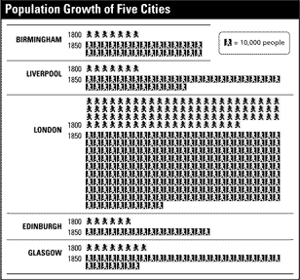
(This chart is for Question 21 and 22)

21.

Which of the following cities had about 320,000 people in 1850?
A | Birmingham
B | Liverpool
C | Glasgow
D | Edinburgh

22.
Which of the following shows the cities ranked from smallest to largest in 1850?
A | London, Liverpool, Glasgow, Birmingham, Edinburgh
B | Edinburgh, Birmingham, Glasgow, Liverpool, London
C | Birmingham, Glasgow, Liverpool, London, Edinburgh
D | Edinburgh, Liverpool, Birmingham, Glasgow, London

-period of art and literature based on nature
-used feelings, emotion, and imagination
-found inspiration in the Middle Ages
23. The above characteristics best describes which of the following artistic movements?
A | Realism |  | B | Impressionism |  | C | Romanticism |  | D | Modernism

24.
Which of the following was a POLITICAL reason why Britain led the Industrial Revolution?
A | Britain had lots of iron and coal.
B | Britain had lots of rich people who became investors and entrepreneurs.
C | The government encouraged industry by spending its money on infrastructure (roads ,railroads).
D | Britain was an island so it could trade with all of Europe.

