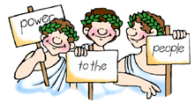
World History – Prologue –

Unit 1-Foundations of Western Thought Leading to Enlightenment and Political Revolutions

Directions: Find the correct or exact meaning of each vocabulary with the help of your textbook and in your own words explain what each word means.
Homework Due Date August 24th. Submit in the haiku dropbox.

Vocabulary Terms and Names: World History text: pages 2-39

1. Government
2. Democracy
3. Direct democracy
4. Republic
5. Monarchy
6. Rule of law
7. The Ten Commandments
8. Illegitimate
9. Tyranny
10. The Republic by Plato
11. Politics by Aristotle
12. Judaism
13. Christianity
14. Islam
15. Authority
16. Ethical
17. moral
18. Code
19. vested
20. philosopher

Use this format
Word | Textbook Definition | What does this word mean in your own words

