Trade Routes
Okay, so. During the era with those huge empires (Classical Civilizations), there were four major trade routes that connected each other. They traded stuff, like, animals, fruits and veggies, and other stuffs. Here are the routes.
I want you to draw the map of Afro- Eurasia and locate the four trade routes and identify what items were traded (who traded what to whom) . Trade items must be drawn and labeled on the map and all important trading ciyies must be named and labeled. This is a good exercise for you to have a mental map engraved in your brain.
COLOR CODE THE TRADE ROUTES
THIS WAS NATALIE’S REQUEST

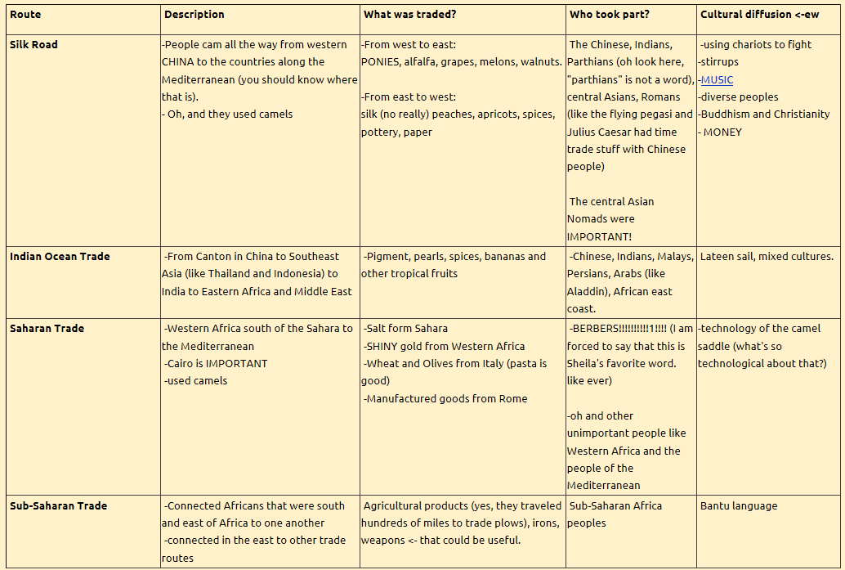
Items traded
    - People (slaves)
    - Technology
      - Stirrup
      - Yokes
      - Saddles
    - Religions
      - Christianity
      - Hinduism
      - Buddhism
    - Cultural beliefs
    - Food crops
      - Qanat system
      - Grapes
      - Rice
    - Domesticated animals
      - Horse
      - Camel
      - Oxen
    - Disease
Methods of trade
Draw the dhow ship, Jung, and ther lateen ship in the waters close to where these three wonderful ships were invented or designed.

