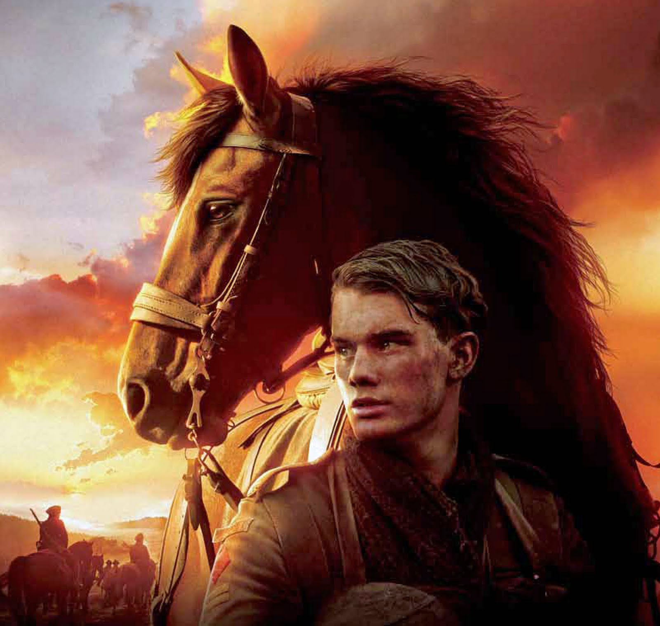

Interactive Project Assignment World War 1

**Introduction**

The movie, War Horse, tells the story of a horse named Joey and his fascinating journey as he travels from rural England to Europe during the First World War This epic adventure provides a wonderful opportunity for students to learn about the historical facts surrounding World War I and what it was like to live during that time period. The War Horse assignment will help you through subjects such as vocabulary, geography and composition as you learn about horse care and farming in the early 1900s, political and strategic European alliances, and World War I weapons and warfare.

[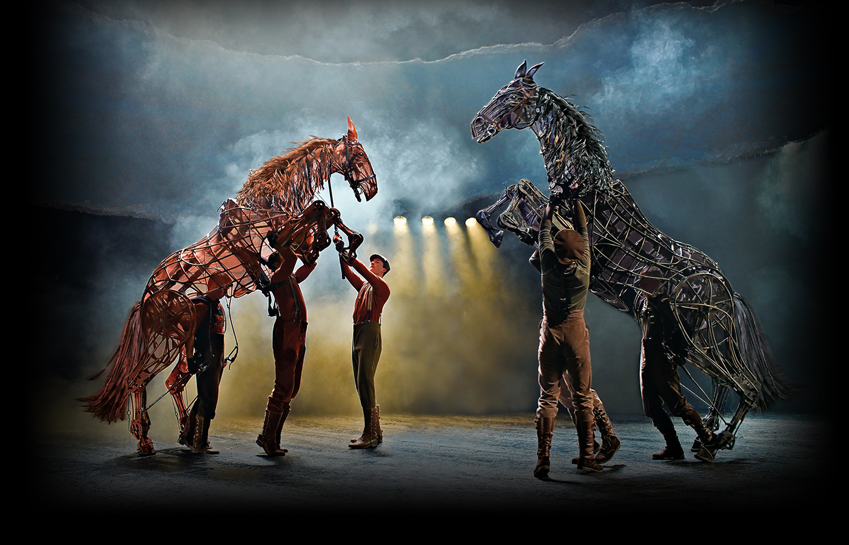](http://www.warhorseonstage.com/)

Right Click on the above picture, select “Open Hyperlink” to take you to the pages of how the movie was produced.

Instructions: Using the information in the sentences below, try to figure out the definitions of the bold words. Then use a dictionary to check your answers

War Horse Vocabulary

Movie Context Clues

1. When Albert was training Joey to plow, he had to make the horse comfortable wearing a horse collar in order to hook him to a harness for plowing.

A harness is ________________________________________________________.

1. Kaiser Wilhelm II, Germany’s last emperor, encouraged several events which eventually spiraled into World War I.

A kaiser is _________________________________________________________.

1. In the movie, Joey was purchased by the British military for 30 guineas. A guinea is equivalent to $1.60 in U.S. currency. Because the price of goods has greatly increased since 1914, the cost of Joey today in the United States would be about $1,080.

A guinea is ________________________________________________________.

1. As the cavalry was preparing to go to battle, they had to make sure there were enough supplies to feed the horses on which each of the men rode.

A cavalry is ________________________________________________________.

1. When the officers realized their troops were outnumbered, they called for a retreat and told their men to move back to a safer location.

A retreat is ________________________________________________________.

6. Providing essential support to the army, the draught (or draft) horse was used to pull carts, wagons, and ambulances to carry supplies and men.

In this sentence, a draught horse is a type of horse that________________________________________________________________.

1. The soldiers pulled their heavy artillery on wheeled carts so they would have larger weapons for the battle.

Artillery refers to ____________________________________________________.

1. During World War I, draught horses often carried munitions for the troops so they would have materials to use for battle.

Munitions are_______________________________________________________.

1. Many battles in World War I occurred while men were sheltered in trenches. After digging a long, narrow ditch in the ground, the men would pile the extra dirt on the battle side of the ditch to make a large, protective wall.

A trench is ________________________________________________________.

1. It is estimated that there were over 35 million casualties in World War I. This includes people injured or killed on both sides of the conflict.

A casualty is __________________________________________________.

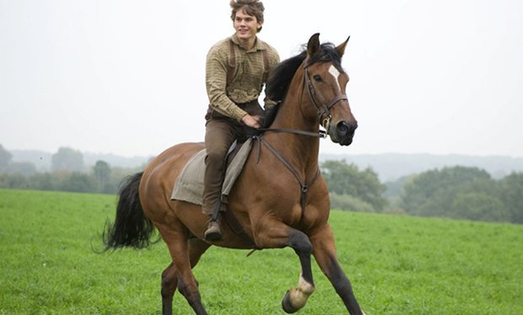

War Horse Vocabulary

Instructions: The information below contains words which are underlined. Look up the definition for each underlined word using its context for clues to its usage and meaning. The vocabulary words are taken from a list of the 100 most common SAT vocabulary words. Write the correct definitions in the spaces provided after the paragraph.

Fascinating Facts About Horses

Typically, a horse needs at least 25 liters

(6.6 gallons) of water each day to keep

from becoming parched.

That is about thirteen times

the amount an adult human drinks daily.

When a foal is born, it quickly gains the ability to escape from predators. Within one hour after birth, a foal intuitively will stand up and then walk. This is not an inconsequential skill in the wild, because a young foal has to be able to travel when the herd travels.

“Horsepower” is an international unit that measures power. It was originally used to compare the power of steam engines with the strength of diligent, hard working draught horses. Though, today, exact measurements differ from between industries, one horsepower is measured as the ability of a horse to pull a specified weight over a certain distance within one minute. Motor vehicles can produce anywhere from a few hundred horsepower to the superfluous amount of several thousand horsepower in the fastest of racing engines. A healthy human can produce about 1.2 horsepower (hp) for a short time and sustain about 0.1 hp indefinitely; skilled athletes are able to maintain about 2.5 hp briefly and 0.3 hp indefinitely.

Easily frightened, horses are wary of their surroundings. The eyes of a horse are located on each side of its head in order to provide a wide range of vision. This enables the horse to see potential dangers while grazing, without having to lift or turn its head, and to take flight if necessary.

The hooves of a horse are made from a protein material called keratin, similar to the protein that makes up human hair and fingernails. Like hair, a horse’s hooves can be cut and shaped without any deleterious results or pain to the animal. As a horse walks and runs, its hooves can wear unevenly, especially if it travels on rocky or paved ground. Because of this, horses need special shoes for protection. Horseshoes are made of metal and are nailed directly onto the hooves once they are renovated by smooth filing and correct shaping.

On average, a horse sleeps two and a half to three hours each day. They do not need to lie down when sleeping because of strategically placed bones and ligaments in their legs. The elastic ligaments connect the bones at the joints in a convergence and lock them together in a special position. This enables the animals to be completely relaxed while standing and to retain their energy and vigor without becoming enervated. Though horses will lie down occasionally to sleep, they are often more comfortable standing up.

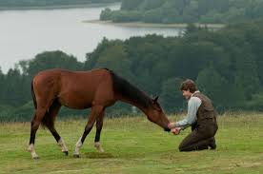

Vocabulary Word Definitions

Convergence _________________________________________________________

Deleterious ____________________________________________________________

Diligent ____________________________________________________________

Enervated ____________________________________________________________

Inconsequential ____________________________________________________________

Intuitively ____________________________________________________________

Parched ____________________________________________________________

Renovated ____________________________________________________________

Superfluous ____________________________________________________________

Wary ____________________________________________________________

Instructions: On the next page is a map of Europe at the beginning of World War I. Using an atlas or the internet, label the listed countries. Then follow the instructions below to learn how World War I began and which European countries were fighting on each side. You will need a green and a blue colored pencil.

War Horse Geography

Countries to label:

|  |  |
| --- | --- |
| Albania  Austria-Hungary  Belgium  Bulgaria  France  Great Britain  Italy  Luxemburg | Montenegro  Netherlands Romania Russia Serbia Spain Switzerland |

1. In the city of Sarajevo, on June 28, 1914, Archduke Franz Ferdinand of Austria is assassinated by a young Serbian man. Write Sarajevo next to the star in Austria-Hungary .

2. On July 28, 1914, Austria-Hungary declares war on Serbia and World War I begins. Color Serbia green and Austria-Hungary blue.

3. Because Austria-Hungary declares war on Serbia, Russia, which was Serbia’s ally, declares war on Austria. Color Russia green.

4. Germany had made a Triple Alliance Treaty with Austria-Hungary and Italy, promising mutual support in the event of an attack by any other large power. Because Russia declared war on Austria-Hungary, Germany was bound to fight a war with Russia. Color Germany blue.

5. France and Great Britain had made alliances with Russia. This was called the Triple Entente. Now Great Britain and France had to declare war with Germany, because Russia was at war with Germany. Color Great Britain and France green.

6. Fill in the squares of the legend. Color the Allied Powers square green and the Central Powers square blue.

*Interestingly, although Italy had an alliance with Germany and Austria-Hungary, it remained neutral until 1915, when it entered the war on May 23 on the side of the Allies. Italy’s justification for not supporting the Central Powers was that the Triple Alliance was a defensive alliance, but Germany and Austria-Hungary had taken an offensive position in the war. It is also worth noting that the United States entered the war on April 6, 1917,on the side of the Allies.*

Europe -1914

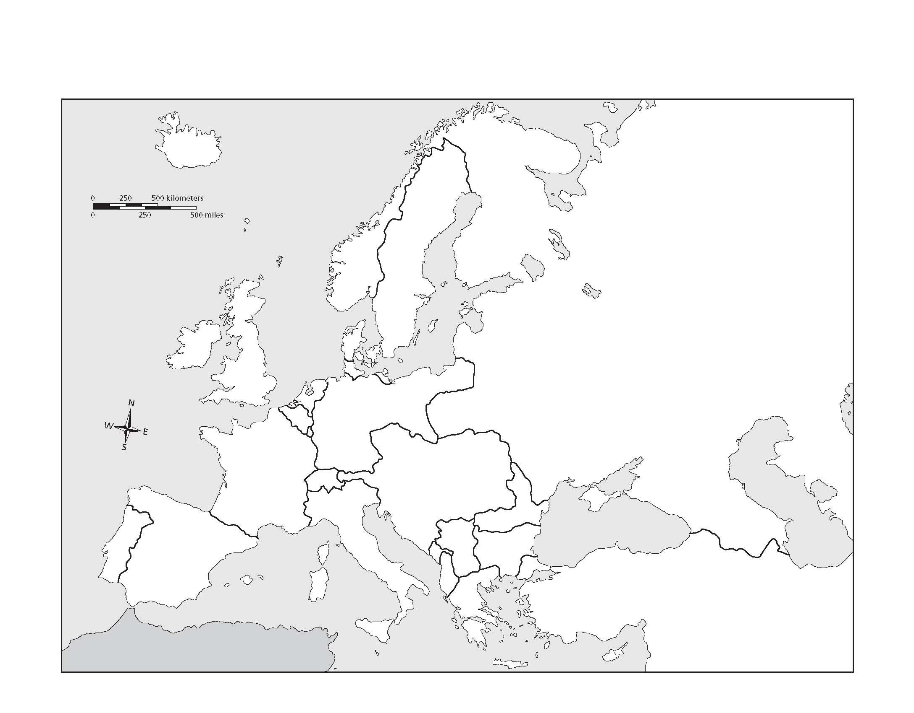

Allied Powers

 Central Powers

War Horse Reading Comprehension

*Answer the questions below after reading the passage. This format is similar to the Critical Reading portion of the SAT exam. time: 10 minutes*

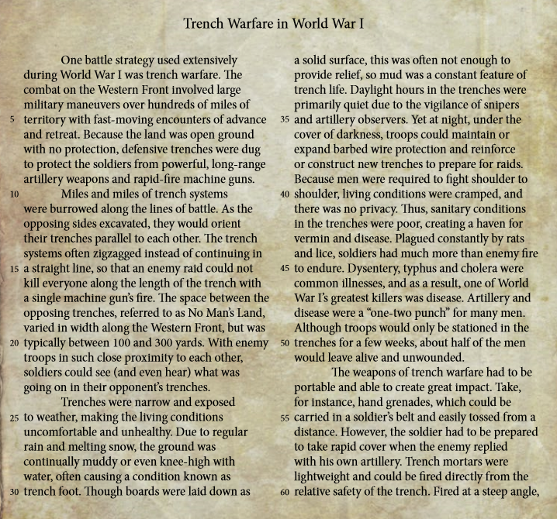

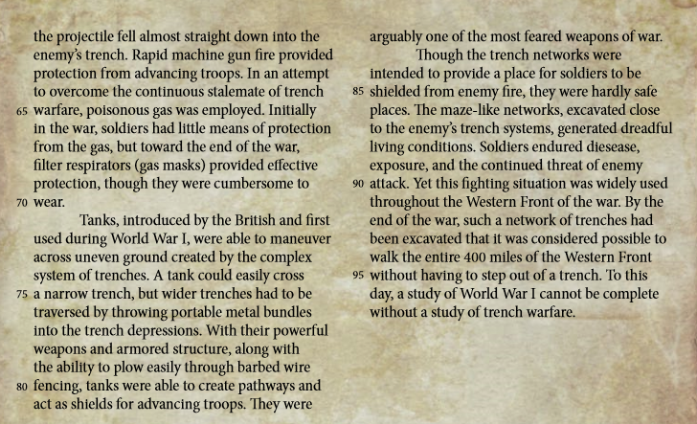

|  |  |
| --- | --- |
| Questions:  1. The parenthetical statement in line 22 (“and even hear”) is included to  a. portray the continual fear soldiers endured b. illustrate the constant need for watchmen  c. emphasize the nearness of the enemy’s trench  d. give the reader a clear mental image  2. The description of mud and water-filled trenches (lines 26-33) chiefly is intended to convey a sense of  a. extreme melancholy  b. a deleterious atmosphere  c. a capacious environment  d. an inconsequential setting  3. The main idea of the third paragraph is  a. life in the trenches  b. trench diseases  c. trench exposure  d. many men died in the trenches | Image result for war horse |

4. When the author writes “Artillery and disease were a ‘one-two punch’ for many men” (lines 47-48) she is speaking

a. hypothetically

b. nostalgically

c. analytically

d. metaphorically

5. When the author says “Take …hand grenades,” (lines 53-54) she is asking the reader to

a. grip the weapon

b. assume it as a typical weapon

c. prefer it as more important

d. consider it as an example

6. The word “replied” in line 57 means

a. conversed

b. retaliated

c. echoed

d. exerted

7. According to the author, which of the following attributes is (are) characteristic of tanks? I. Invulnerable II. Relentless III. Conventional and Commonplace

a. I only

b. II only

c. III only

d. I and II only

e. II and III only

8. The use of the word “arguably” in line 82 is to show

a. people liked to argue about tanks

b. some may disagree with tanks being more fearsome than other weapons

c. military strategists do not agree if tanks should have been used in the war

d. historians do not consider tanks to be weapons

9. All of the following statements about trenches can be inferred from the passage EXCEPT

a. men had lots of solitary time to think in the trenches

b. trenches were difficult to keep clean and orderly

c. sleeping would be challenging in trenches

d. there was a continual feeling of expectancy of an attack

10. The main purpose of the passage is to

a. discuss the various battles of World War I

b. report on the weapons of warfare

c. summarize the conditions of warfare

d. explain the enviroment of trench warfare

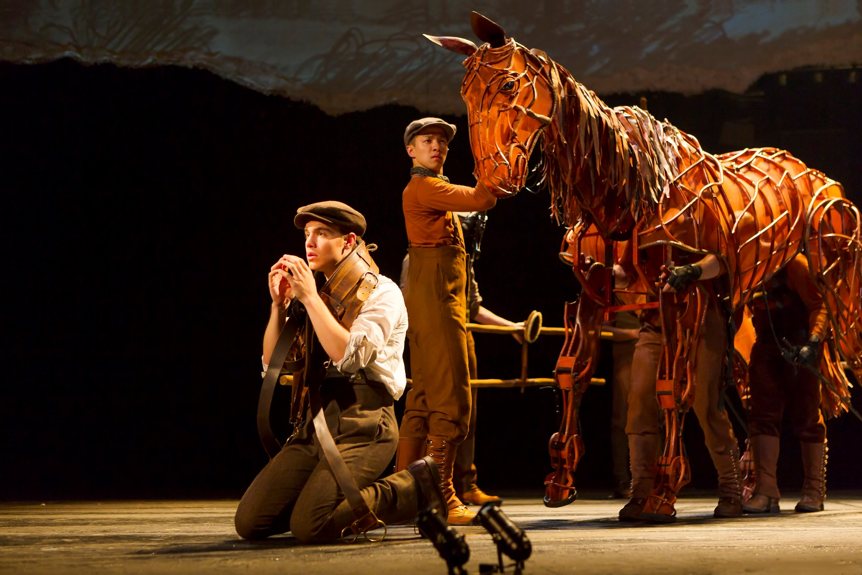

Analyzing primary source document

War Horse- Life in the Farm

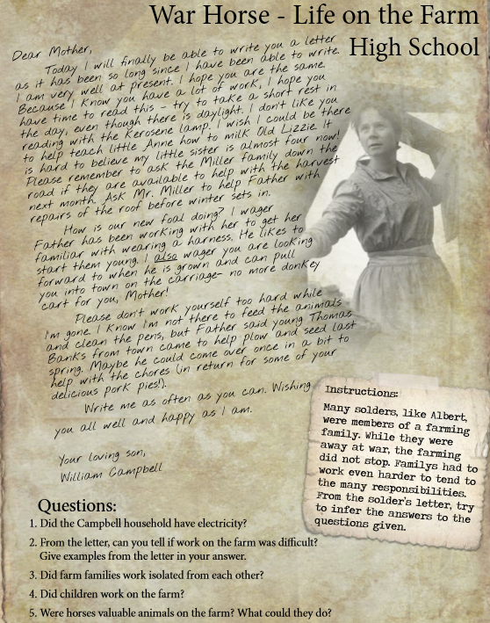

Answers:

War Horse Essay

*World War I affected more civilian locations than battlefields. The consequences of war reached to all of Europe and even other continents. The people, like Albert’s family, living in the Devon area of Great Britain had to endure many hardships throughout the war. Often their only information came from the local newspapers. Using the headlines from a newspaper similar to one that may have been distributed in Devon, write a paper that describes what life was like for those living in Albert’s community during the course of the war. Include the important political events as well as the local concerns that faced this rural farming community*

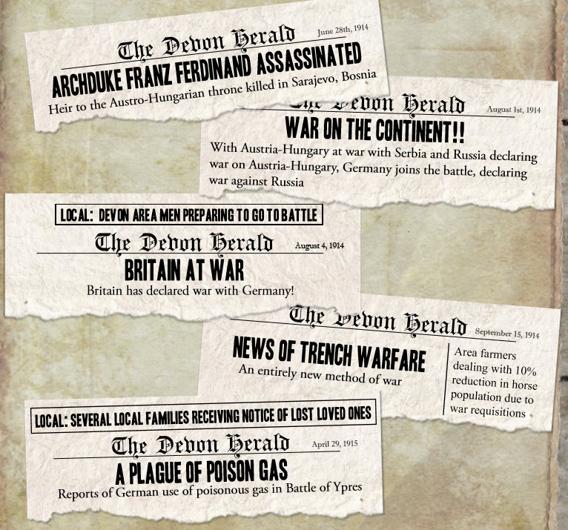­­

Doc 1

Doc 5

Doc 4

Doc 3

Doc 2

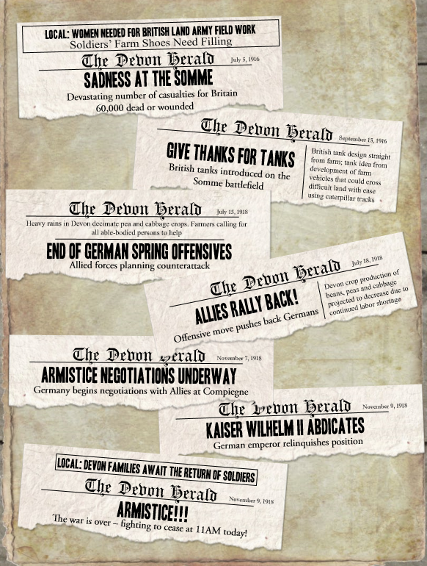

Doc 12

Doc 11

Doc10

Doc 9

Doc 8

Doc 7

Doc 6

Document Base Analysis Question

**Based on the 12 documents of the newspaper headlines, write an essay describing what life was like for those living in Albert’s community during the course of the war. Include the important political events (from the news paper article headlines) as well as the local concerns that faced this rural farming community (as viewed from War Horse).**